Communication Policy Book - Payoneer Platform Real estates
Original by: Mor Rahimi

Comm Channels – Product, Ownership, Device & Format Support Status 06-2025 2
Interim Jumbotron [Promotional] Policy 3
Welcome Banner Policy 5
Alerts Policy 9
What’s New- MVP 14
Current Notification Center [In-app] Policy (Draft) 19
The "What’s New + Notifications" Feature 26
High-Level Product Capabilities 26
Tour Guide / Tooltip Policy 34
Banners Policy 39
First-use States Policy (Overview) 43
Drive to FFT First-use State Policy 45
Product - Upgrade First-use State Policy (MVP for Upgrade/Offering) 47
Product First-use State Policy (Vision) 54
Financial Management First-use State Policy 69

Interim Jumbotron [Promotional] Policy

Date: April 1st, 2024
Approval: Currently approved by Marketing (Ankur)
Still open: Legal approval for disclaimers
In production: Yes

Policy Definition:
- KPI? How do we define success?
  - Every Jumbo must have CTA (for CTR)
  - Every Jumbo must have a definition of success (exact number) -Marketing
    - I.e. Adoption, Visibility etc.
    - Estimated target: ~12%
- Who can define communication
  - Marketing
- Who must sign off on communication
  - Mor Rahimi (Product) – only for early life for alignment purposes (Directly from Liron)
- Audience configuration options / restrictions
  - Only allow Jumbo to appear for relevant, eligible population (i.e. a feature not available in a certain region should not be displayed) [legal requirement]
- Messages allowed
  - Types of messaging (promotion / upsell / what’s new / alerts)
    - Currently allowed: upsell / new features / alerts
    - Not allowed: education (FAQ – external links), events, call to interact & social
  - Messaging category (transactional / marketing etc)
    - Currently: upsell / new features / alert
      - Future – put it in a BO list
  - Call to action definition
    - CTA must appear
    - Must always be an internal link inside the platform (external links that take our of the platform are not acceptable)
- Delivery time (if a limitation exists)
  - View 1 jumbo in the same session (already happens today)
- Cool off period between notifications
  - Will be defined in the future (today BO doesn’t have it – Comms may have it – Yonatan’s team)
- Reminders (if relevant)
  - Up to 2 time reminder of the same Jumbo
    - Can we define a cool-off period for this? So reminders aren’t too intrusive? [Another Jumbo]
    - Languages (if relevant)
  - Must be localized to the account language to best of ability [rare irregularities]
- Ecosystem – Channels
  - Will be defined in the future
- Does it require a testing period before hand?
  - If it’s a new feature – create experiment with & without the banner to test effectiveness.
- Risk
  - Currently Marketing does not have analytics at their disposal, which leads them to create campaigns without an understanding of their success/failure. Therefore we see a spike in Jumbo campaigns & inability to prioritize between them.
    - Mitigation:
      - Alert channels to reduce the volume so they can focus.
- Design guidelines - Figma
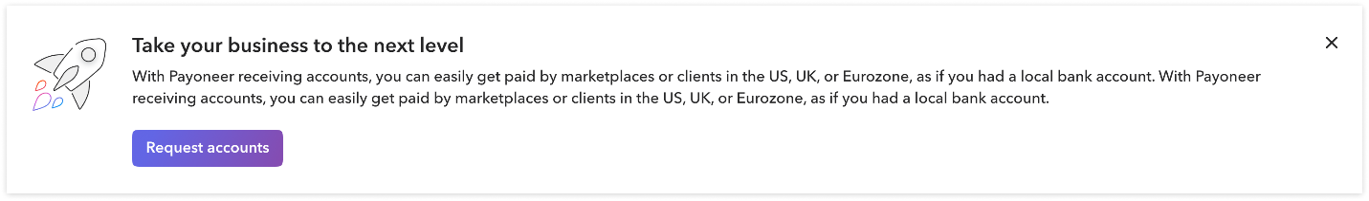
  - Template options/configurable & content restriction
    - Title (mandatory) - Up to 100 characters (one-line)
    - Sub-title (optional) - Up to 260 characters (two-lines)
    - Bullets (optional) - Max 4 bullets. The bullet text should be in one line
    - CTA (mandatory): Must always be an internal link inside the platform (external links that take outside the platform are not acceptable)
    - Icon image - LVL 3 (100x100) - aligned to left. Spacing between the icon to the text should be 24px
    - Text font - Avenir. Color - Grey 700. Aligned to left.
    - Title - Avenir Demi 24px. Sub title - Avenir Regular - 18px.
    - X (mandatory)
    - Banner shadow - Elevation/Default
    - Spacing - Top & bottom: 32px. Left & Right: 24 px
    - Do not have legal T&Cs & disclaimers [unless major eligibility issues arise]
    - NOTE: we will use early life program as a test to define it finally

Welcome Banner Policy
Date: June 2024
Approval:
In production: Yes

High-level description of product:

An early life banner that showcases 3 early life money-in & mobile products to allow the user a smooth onboarding after approval to begin adopting Payoneer products.

Today we support the following 5 products:
- Receiving accounts
- Request payment
- Add funds (coming soon)
- Marketplace
- Mobile

High-level product capabilities:
- The banner will appear only upon account approval
- The banner will always promote up to 3 early life products (money-in & mobile)
- The products relevant in each banner (i.e. ‘product components’) will be set based on eligibility & prioritization per country.
- The banner will disappear once the user does FFT

Policy Definition:
- KPI? How do we define success?
  - Every product component will track success parameters in accordance to click on the CTA.
    - Note: each product component must have an internal CTA leading to a product within Payoneer with the exception of mobile that takes to a QR code.
  - Success will be assessed on 4 levels:
    - Click on specific product component
    - Begin opt-in for product
    - Completion of opt-in for product Adoption of product (FFT)
- Who can define product components? Adding/removing components.
  - Raz Ariel (communication product)
    - With the help of Marketing in terms of content & animations.
- Who must sign off on communication?
  - Raz Ariel (communication product)
- Audience configuration options / restrictions
  - Each component product within the welcome banner should be configured based on:
    - Eligible population (i.e. a feature not available in a certain region should not be displayed) – automatic configuration within the product logic.
    - Prioritization based on country (i.e. in certain countries may wish to promote more ‘Add funds’ instead of ‘Payment request’) – defined by product (with marketing/business recommendation).
- Messages allowed
  - Types of messaging - promotion of early life (money-in) products & mobile.
  - Messaging category – product marketing
  - Call to action definition
    - CTA must appear
    - Must always be an internal link inside the platform with the exception of mobile (external links that take out of the platform are not acceptable)
- Delivery time (if a limitation exists)
  - Banner will appear until:
    - User presses ‘x’
OR
    - If the user has less than 3 relevant products the banner will disappear. Options leading to less than 3 products:
      - The products the user has begun opt-in to + the number of (didn’t implement) products the user is eligible for is less than 3.
        - NOTE: Mobile & marketplace are two early life product components that do not require eligibility
OR
    - 30 days have passed & at least 2 logins on different dates (didn’t implement)
  - NOTE: Can define number of use (currently not defined) – i.e. after 3 views will disappear.
- ‘Product component’ prioritization
  - Product requires that:
    - Marketplace will always be last in the welcome banner
  - The rest of the money-in product prioritization will be determined by product with the option of moving it to business/marketing
- Cool off period between notifications
  - Currently in the BO we do not have a mechanism for cool off period and therefore it was not implemented in MVP.
    - Will consider in the future adding a cool-off period such that between every time the user sees the welcome banner (for example if 3 views are defined) they will have a cool-off period of X days or Y logins.
- Reminders (if relevant)
  - Can define number of use (currently not defined) – i.e. after 3 views will disappear.
    - Leaning towards 2 views. *Raz will investigate with Yehoshua if there’s a way to track the behavior per view (i.e. if we should the user the welcome banner after ‘x’ again – how many converted?)
  - Must be localized to the account language to best of ability [rare irregularities]
- Ecosystem – Channels
  - While the welcome banner appears, only Alerts can appear on this top homepage real-estate. Meaning, the Jumbotron cannot be visible as long as the Welcome banner is visible.
- Does it require a testing period before hand?
  - When a new product is added, A/B testing is required to understand the impact on:
    - Time to FFT
    - FFT rate
    - Other money-in products
- Risk
  - Did we manage to cover eligibility by 100%?
- Design guidelines - Figma
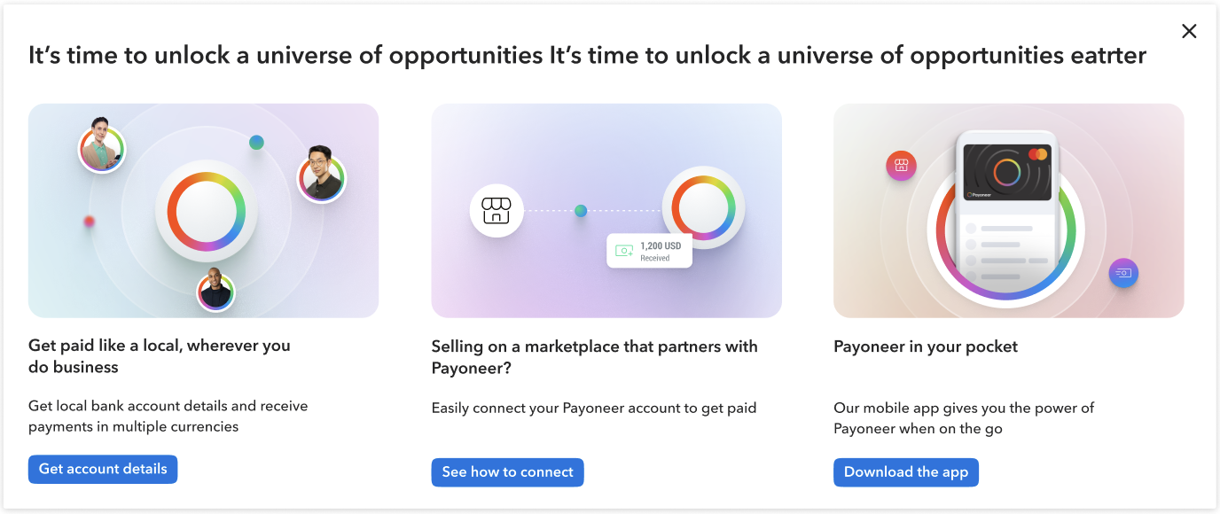
  - Template options/configurable & content restriction
    - Title (mandatory) - Up to 100 characters (one-line)
    - Card title (mandatory) - Up to 80 characters (two-lines)
    - Card Sub-title (mandatory) - Up to 90 characters (two-lines)
    - Card CTA (mandatory): Must always be an internal link inside the platform with the exception of mobile (QR code).
    - Card visuals – JSON animation, rectangle with corner radius 16
    - Card inner spacing – 16px between animation, title, subtitle, CTA
    - Banner spacing – Right & left: 24px. Top & bottom: 32px. Between cards: 48px
    - Text font - Avenir. Color - Grey 700. Aligned to left.
      - Title - Avenir Demi 24px. Card title - Avenir Demi 16px. Card subtitle – Avenir Medium 14px
    - CTA - XXS
    - X (mandatory) - grey 700
    - Banner shadow - Elevation/Default
    - Banner corners – corner radius 2
    - Should be 3 products (cards) - if there are less than 3 products will the banner disappear?

Alerts Policy

Date: December 2024
Approval: Aligned with Marketing (Ankur)
Still open:
In production: Yes (December 2024)

High-level description of product:

Account Alerts. Customers can now easily differentiate between critical and non-critical actions in their account, allowing them to resolve issues independently. With clear, actionable and prioritized updates on the homepage, customers are empowered to take prompt, informed action.

High-level product capabilities:
- Prioritization between alerts (critical>success>warning>informational)
- Definition of what Alerts can appear with one another
  - Ex. Warning will not appear with Success; Critical will always appear alone.
- A total of 3 alerts can appear within the interface as a given time
- Informational alerts – can specifically define an info alert that trumps the rest
- Warning alerts – will show the aggregation of requirements that are necessary for making sure the payment does not get stuck / account isn’t blocked.

Policy Definition:
- KPIs
Primary KPI – View, Click & Completion of action (I.e. submission / update info etc.)
- Who can define: Marketing OPS
- Who must sign off: Communication (for release period – 1 month)
- Types of messaging per severity
Critical
  - Messages allowed
    - Currently allowed: only allowed message: Your account is restricted
    - Not allowed: all the rest
  - Messaging category Account administration
  - Call to action definition: None
  - Cool off period between notifications Appears as long as the account is restricted & no other alert will appear simultaneously.
  - Ecosystem –No jumbotrons allowed while critical alert is displayed.
  - Guidelines/Logic
    - No X option
    - No title allowed
    - Content predefined by Communication team
  - Can disappear if:
    - Account is unblocked
  - Combination of alerts:
    - If a critical message is presented all other alerts won’t be presented.
  - Prioritization within Critical alert:
    - Only one can be displayed at any given time (only one use-case)

Warning
  - Messages allowed
    - Currently allowed: Only alerts that notify of an action that may block the account / stop payments capabilities
    - Not allowed: All the rest
  - Messaging category Account administration
  - Call to action definition: CTA that leads to verification center - mandatory
  - Cool off period between notifications Appears as long as FDC requirements are open.
  - Guidelines/Logic
    - No X option
    - Title allowed
    - When there is more than one requirement open – it should be aggregate in one alert such that at all times one warning alert can appear.
    - A default message will appear stating there are few (number) open requirements and all alerts would be aggregated.
  - Can disappear if:
    - User completes submission
  - Combination of alerts:
    - In a warning alert is presented cannot appear with Critical or Success alert.
    - Warning alert can appear with informational alert.
  - Prioritization within Critical alert:
    - Requirements will always be aggregated such that only one warning alert can appear at a given time.

Success
  - Messages allowed
    - Currently allowed: Only Your account is approved message (in the future account upgrade). Future success message can be added as long as their relevant to the entire account status.
    - Not allowed: All the rest
  - Messaging category Account administration
  - Call to action definition: No CTA allowed
  - Cool off period between notifications appears in the first two logins (will be monitored to check the effect)
  - Guidelines/Logic
    - X mandatory
    - Can add title
  - Can disappear if:
    - User presses ‘X’
  - Combination of alerts:
    - Can be displayed with Informational alert
    - Cannot be display with warning & critical
  - Prioritization within success alert:
    - Will show one per page based on what was triggered first, once closed, triggers the one after.

Informational
  - Messages allowed
    - Currently allowed: (marketing NOT allowed)
- Every message that contains information that might affect or affects the account but doesn’t require any verification action from the user
    - Not allowed: all the rest
  - Messaging category Account administration
  - Call to action definition: CTA optional
  - Cool off period between notifications one informational update at a time by priority
  - Guidelines/Logic
    - X mandatory
    - Title allowed
    - Must have expiration date.
  - Can disappear if:
    - User pressed ‘X’
    - User pressed CTAs
    - Expiration date has passed
  - Combination of alerts:
    - Cannot appear with critical message
    - Can appear with success & warning.
  - Prioritization within Critical alert:
    - Will appear based on creation date up to 1 informational alert at a given time, once it disappears with via ‘X’ / CTA click / expiration date, the next informational alert will appear.
    - Have an option to set one ‘High priority informational’ to trump all the rest of the alerts.

Alerts design guidelines
Desktop view:
- Icon: Fontawesome 24px
- Title: Avenir Demi 16. Aligned to left. Max characters - 130
- Description: Avenir Medium 16, Max characters - 260
- CTA: outlined button, 36px height, button text: Avenir Demi 16 – 20 characters is the absolute maximum
- "X" icon: fontawesome 20px

Figma
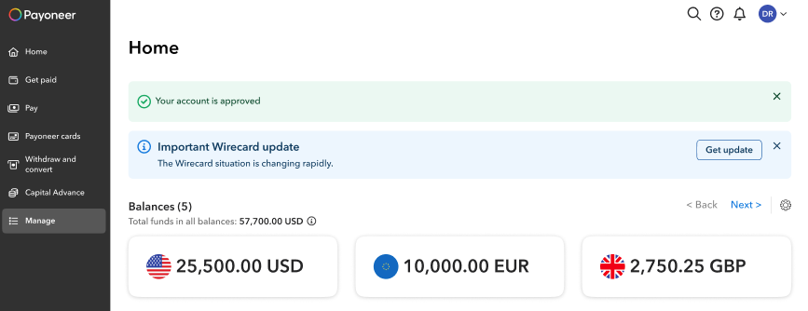
Figma link: https://www.figma.com/design/GDdFBQMo8auMUPPIYUi1LT/Communication-channels?node-id=428-14772&p=f&t=vEIfJL8jwEZQWrL0-0

Mobile view:
- Icon: Fontawesome 20px
- Title: Avenir Demi 14. Aligned to left. Max characters - 130
- Description: Avenir Medium 14, Max characters - 260
- CTA: outlined button, 28px height, button text: Avenir Demi 14
- "X" icon: fontawesome 20px

Alert Combinations Table:

Alert | Shown alongside
Critical | NON. Shown alone only
Warning | Informational update
Informational update (NOT marketing) | Warning or Success
Success | Informational update

What’s New- MVP

Date:
Approval:
Still open:
In production: No (set for Q1 2025)

The "What’s New" feature is an in-app channel designed to drive awareness and potentially cross-sell and up-sell by informing customers about new features, updates, and new product enhancements, encouraging engagement and adoption.

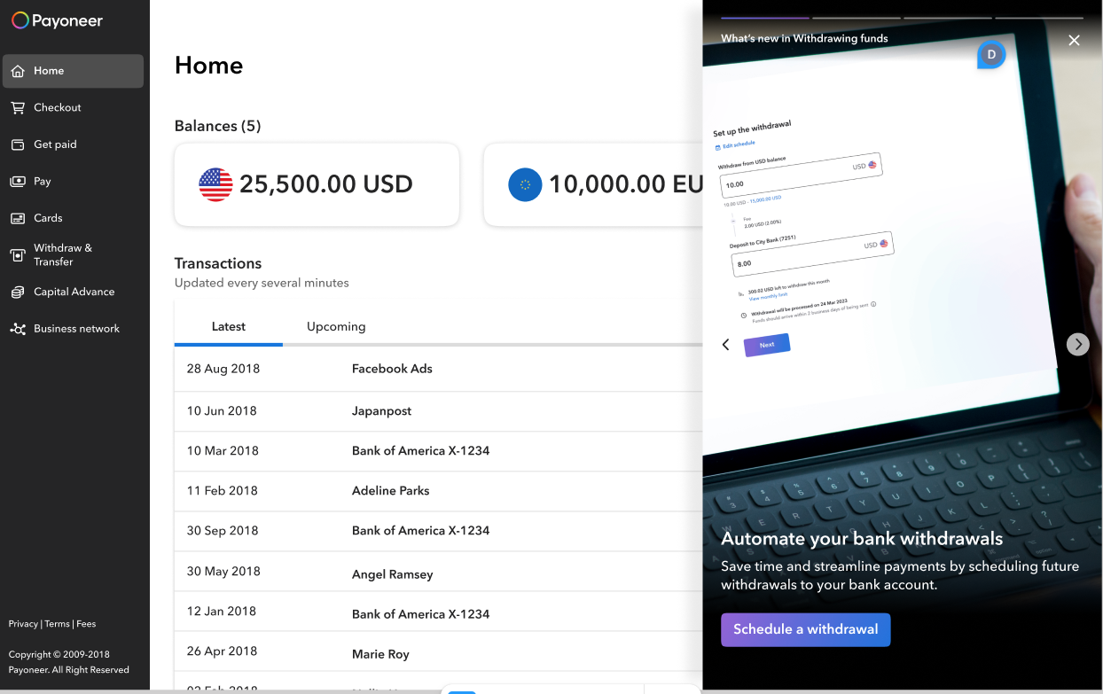
Figma link: https://www.figma.com/design/GDdFBQMo8auMUPPIYUi1LT/Communication-channels?node-id=3791-49987&t=eqZUm1fI9iGRu63K-1

High-level description of product:
The "What’s New" feature provides an in-app communication channel to inform users about new features and updates that were released. This feature addresses the gap in communicating new feature/product released and driving adoption, especially for unmanaged customers. It delivers timely, relevant updates within the platform, encouraging engagement and adoption of new features and more importantly, directing them to the relevant area to begin using the feature/product. Future versions will allow customization for different segments, will include eligibility and could potentially also allow discoverability of untapped products.

High-level product capabilities:
- Dedicated Channel: Separates product announcements from other notifications.
- Regular Updates: There is no limit on the number of new features announced per month.
- User Action: CTAs/links drive users to take action within the account.
- Responsive UI: Fixed-width panel for desktop/tablet, mobile design for smaller devices.
- Engagement: Carousel format for easy navigation.
- Beyond experiment: story-like behavior

Policy Definition:
- KPI? How do we define success?
- Engagement rate: the rate of clicking on the component (The arrow) that takes you to the next step.
- Adoption rate: The impact on adoption/start of the adoption process of the capability or feature which are presented
  - Here may need to look at 2 KPIs:
    - Start of the funnel
    - Completion of wanted action
- Who can define communication:
  - Product marketing: Provides messaging content for announcements, ensuring alignment with Payoneer’s voice and marketing strategy
    - The initial stage of ‘What’s new’ will be a part of the QPR and the messaging will be defined as part of initiative. Hence, the user will experience update once every 3 months. In order to allow for a smoother running experience and because we do not want to invest in automation right off the bat.
- Who must sign off on communication: Marketing Team
- Audience configuration options / restrictions:
- Experiment does include:
  - Segmentation
  - Eligibility
    - This means that first phase will only be announcement that are relevant to ALL AUDIENCE.
      - Future: do we want to allow users to see them & potentially upgrade to receive them?
- Target Audience: Primarily unmanaged customers who will benefit from knowing about new features, product enhancements, and updates. Future updates may include customizable options based on user segments.
- Messages allowed
  - Types of messaging Feature Announcements:
    - Currently allowed: New features/product and product enhancements
    - Not allowed: Everything else –
      - Platform Updates: System improvements and backend updates that impact user experience.
      - Upselling untapped features (may want to test this in the future but is currently not allowed)
  - Messaging category marketing
  - Call to action definition: CTAs: Must direct users to take actions within the account (e.g., clicking on a feature link to try a new tool). No external links allowed.
    - When ecosystem play come into being we’ll revaluate opening this up to partnerships
- Can disappear if:
- Panel disappearance:
  - The panel will close if the user clicked anywhere outside it on the page, or on the X icon.
  - When the panel is open the page under it is still active: the user can click on a page element and it will trigger the element or scroll the page when the panel is open.
  - No background when the panel is open
- Feature/update disappearance:
  - We will not maintain a historical record of past announcements.
- Delivery time Updated at the beginning of each quarter
- Queuing: NA
- Appearance policy:
  - Can be opened (there is an option to open) only from within the HP (For MVP only. This is due to development challenges on the account shell on internal pages.). Opens when the user clicks on the new icon in the right part of the interface header
- Cool off period between notifications
- Reminders (if relevant)
- Ecosystem – Channels: Can be found at the same time with all existing channels on HP, without limitation
- Does it require a testing period beforehand? MVP planned in Q125
- Risk:
  - Eligibility risk- Users will be exposed to or redirected to products they cannot access or use, that are not open to them.
- Design guidelines:
- Structure:
  - Header: The gallery item category will be displayed under the Gallery indication component, on the left of the panel.
    - The category text will be max 36 characters long. It is H5.
  - Title – H2: The title should be max 80 characters long. It can overflow to 2 or 3 lines as needed in the device’s display.
  - Text - Lead paragraph: The text should be max 100 characters long. It can overflow to 2 or 3 lines as needed in the device’s display

- Guidelines:
  - The Title, Text and CTA button will be aligned to the left.
  - They will have fixed spacings between themselves and from the bottom the panel. 8px between the Title and text. 24px between the text and CTA.
  - If the Title or the Text are long, it will push the rest of the components up - the spacings between the components themselves and the bottom of the panel will not change. 56px CTA from the bottom.
- Panel behavior & design:
  - The panel will open from the right with a fixed width on desktop and adapt to mobile screens on smaller devices. It should not obstruct the user interface or interfere with ongoing tasks.
  - Clicking on the megaphone icon in the header will open the “What’s New” panel
  - The panel opens from the right with a fixed width on desktops. Its height matches the device screen.
  - Users can close the panel by clicking outside it or on the X icon. While open, the page behind the panel remains interactive and scrollable.
  - The panel features a drop shadow overlay and an image background (MVP). Navigation is carousel-style, with arrows to scroll between items, looping seamlessly from the last to the first. Clicking on the right arrow will scroll to the next “What’s New” item. Clicking on the left arrow will scroll to the previous “What’s New” item. This is a carousel, and you can scroll right from the last item back to the first and the other way around
- Badge behavior:
  - The badge on the bell will only be displayed if the user has unread “What’s New” items.
  - The badge will remain until the user opened the “What’s New” panel, and then it will disappear, even if the user didn’t click anything inside the panel or see all the stories.
  - Next time a new batch of ‘What’s new’ appears, the badge will reappear.

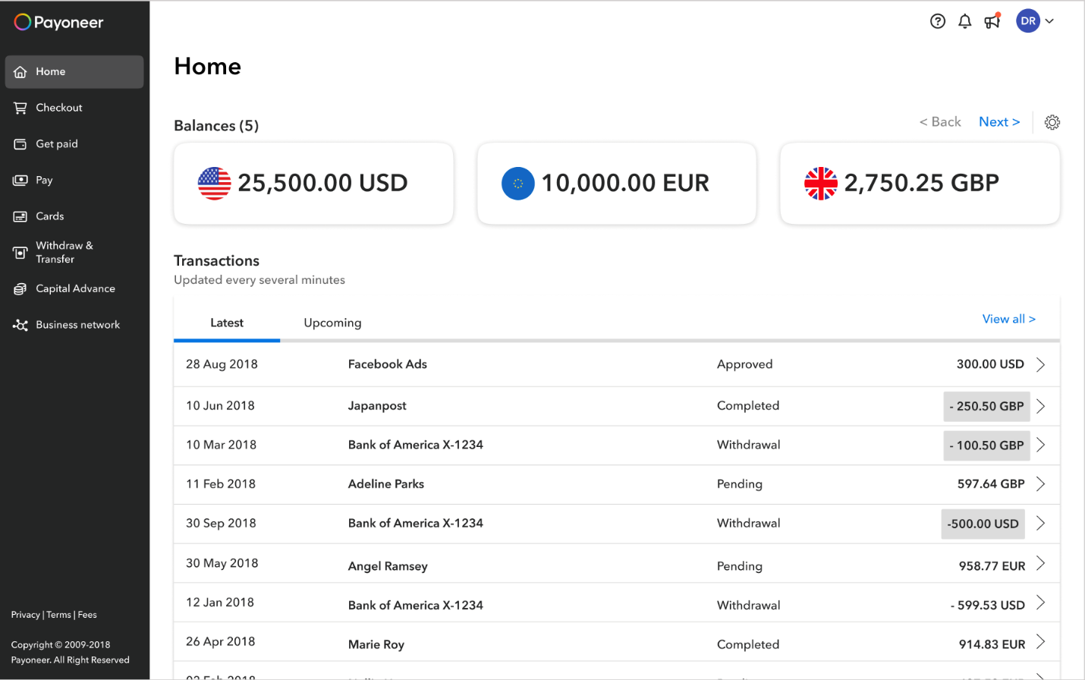
Image & Content guidelines for ‘What’s new’ products/features:
- The background image should cover the entire panel.
- If the image is too light in colors at the top, add a mask to the image (design in Figma). The Gallery indication, the Header text and X button should be clearly visible.
- If the image is too light in colors at the bottom, add a mask to the image (design in Figma). The Title, text and CTA button should be clearly visible.
- The category text will always start with the words “What’s new in” and then the category name (for example “Making payments”).
- There should always be a Category text, Title, Text, and CTA button.
- The CTA button will lead directly to the relevant action page inside Payoneer.

Current Notification Center [In-app] Policy (Draft)

Date: January 2025
Approval:
Still open:
In production: Yes

High-level description of product:
The Notification Panel is an in-app feature that provides users with timely updates. These notifications focus solely on essential information like account updates, security alerts, and transaction changes, ensuring users stay informed about important developments without including any promotional or marketing content.

High-level product capabilities:

- Provides real-time, operational notifications
- Users can filter notifications by "All" or "Unread" for easy management.
- Notifications can be marked as read individually (by opening them)
- All messages are saved according to the date they were sent. Users can delete messages at will.

Policy Definition:
- KPI? How do we define success?
- Notification open rate
CTA Click Rate - Currently not measured
- Who can define communication: Any product manager, no governance
- Who must sign off on communication: Avi Castro (Operations)
- Audience configuration options: all users
- Messages allowed
  - Types of messaging Operations and transactional
    - Currently allowed: Operations and transactional
    - Not allowed: marketing etc
  - Call to action definition: There is no requirement to include a CTA, there is no mandatory format for a CTA. Some messages include a CTA that leads to or off the platform
- Delivery time NA
- Cool off period between notifications: There is no limit or control on the number of messages on the same topic that can be sent to users.
- Reminders (if relevant) NA
- Ecosystem – Channels: In most cases (although not automatically) the exact content of the notification is also sent by email. Many notifications are, in effect, a copy of an email.
- Does it require a testing period beforehand? no
- Risk
- Design guidelines -
  - Currently there is no restriction on format, text length or headline/CTA requirement or any design and style settings. The text in the notification can be of any length, and include a table, lists, links, CTA button, several paragraphs, with or without a title.
  - The notifications page systematically organizes notifications based on the sequence they are received, ensuring a chronological display. Each notification entry is accompanied by a title and the date of dispatch. Upon clicking a notification, a right-hand panel unveils the complete message content. For longer messages, users can scroll through the panel to read the entire content.

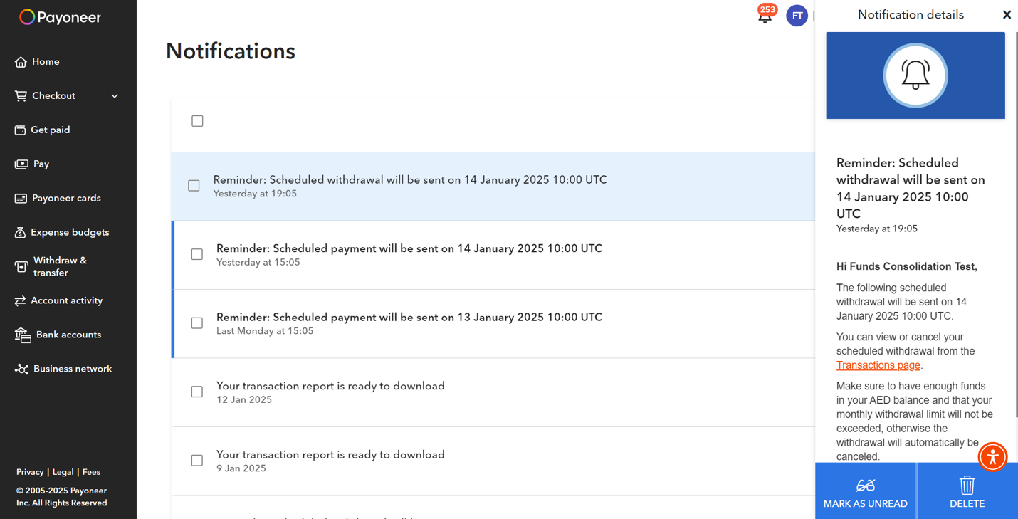
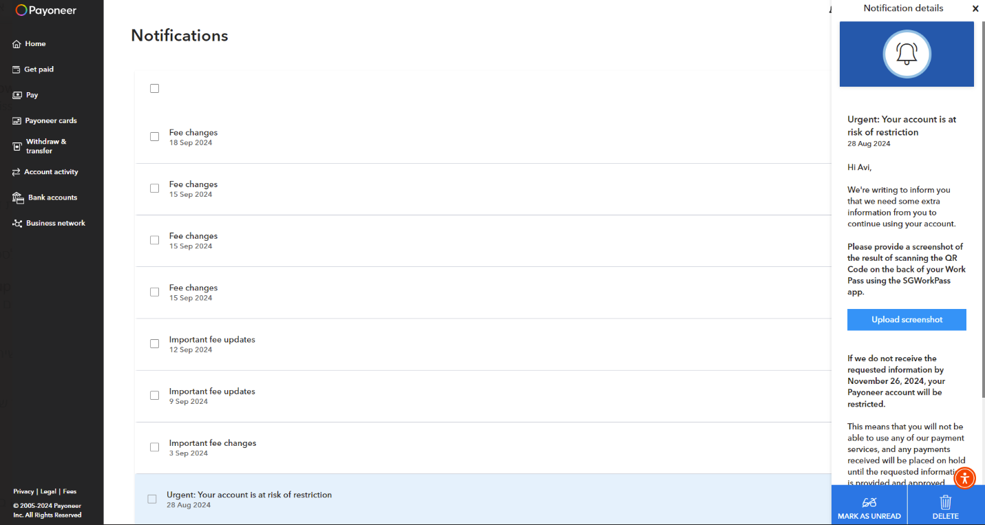

What's New+ Notification Panel - Unified Vision

Date: January 2025
Approval:
Still open:
In production: No (Currently not planned – Jan 2025)

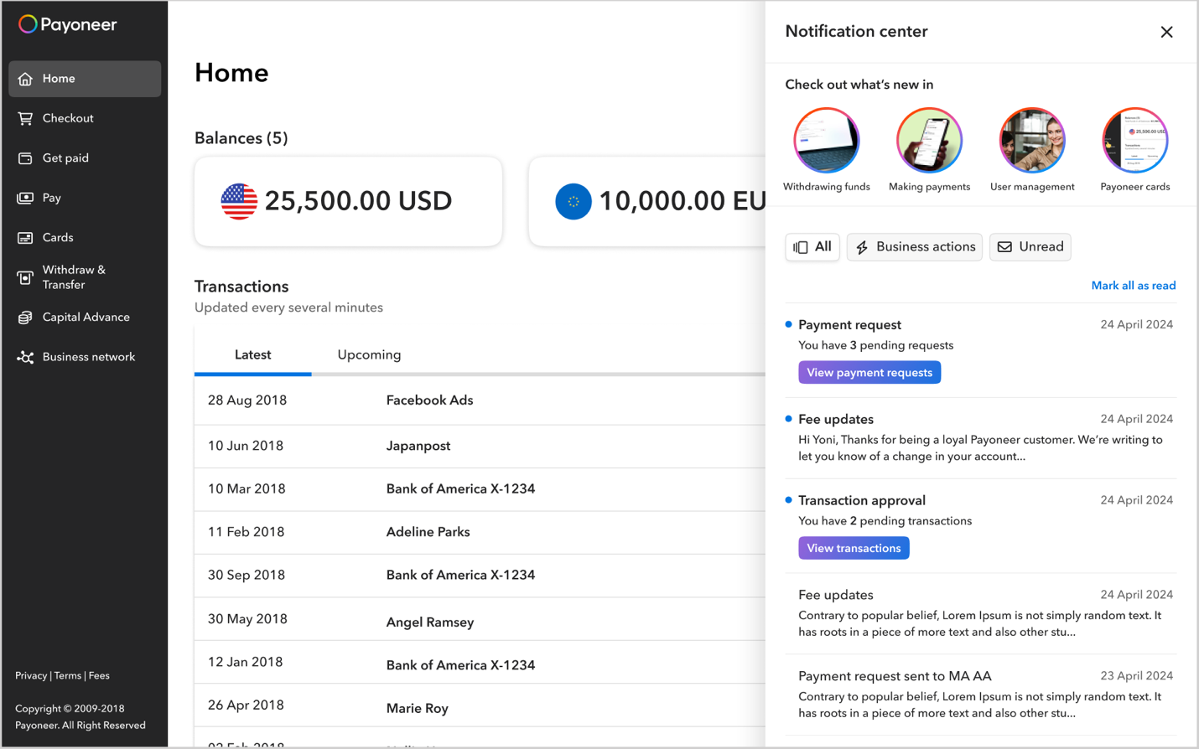
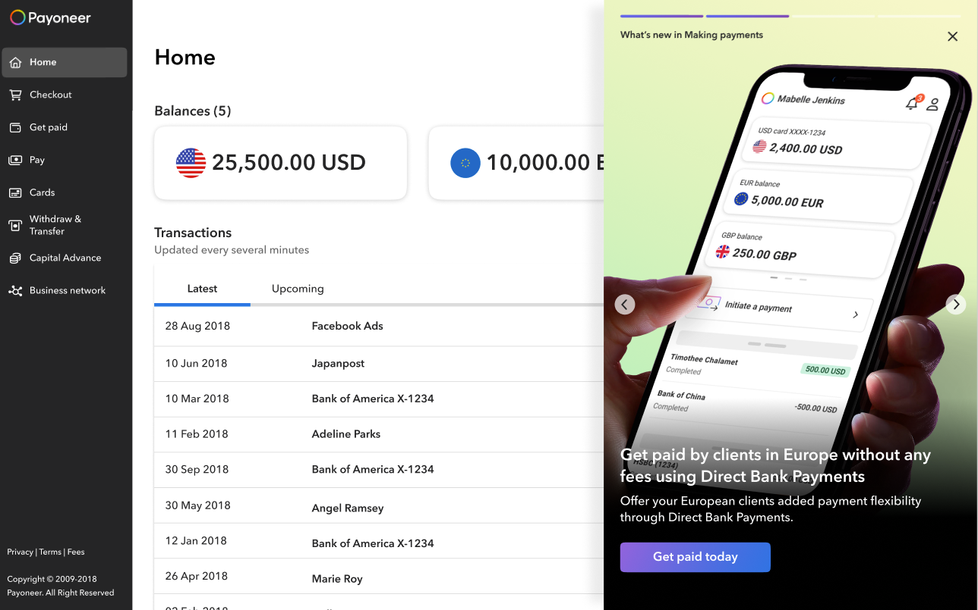
What’s New stories (in the final Notifications panel)

When the What’s new panel will merge with the Notifications panel, stories will appear (circles with images and title) to indicate how many new stories there are to view.

When there are more than 4 stories, the left part of the 5th story will appear, to indicate there are more stories to view. Interaction in this extended gallery will be by scrolling horizontally. In mobile the interaction is left and right slide.

All together

The combined panel’s behavior will follow the previous “What’s new” panel & “Notifications panel” behavior with the following adjustments:

Homepage

The megaphone icon will disappear, and the bell icon will open the combined “What’s New” + “Notifications” panel.

The bell icon will have a badge with a number to indicate:
- A new notification that is unread.
- A new “what’s new” story set (since the stories are added together as a set and the previous stories are removed).
  - Despite stories being uploaded as a set, if the set includes 4 stories, the badge number will be “4”.
  - Even if only one story was opened the badge indicating new stories will disappear.

Notifications panel

The new panel will include the following:
- “What’s new” stories section.
- All previous content of the Notifications panel, including the filter, notifications, business actions notifications, etc. There is no change in the behaviour of any of these items.
- A divider separating them.

What’s New stories section

The stories section has a fixed title: “Check out what’s new in”. It is H4.

The stories are circles with images and the gallery item category. Each has an indication if they are “read” or “unread” (a colored circle stroke). If a story is “read” the circle will become grey.

The stories circles indicate how many new stories there are to view in the gallery. When there are more than 4 stories, the left part of the 5th story will appear, to indicate there are more stories to view. Interaction in this extended gallery will be by scrolling horizontally. In mobile the interaction is left and right slide.

Under each story’s circle there will be the gallery item category that this story is part of. It is 12px. It is 16 characters maximum, and if longer will show an ellipsis.

Clicking on any of the stories, read or unread, will open that story’s gallery item.

“What’s new” gallery header

A “back” arrow will be added to each gallery item, to the left of the item category. Clicking the arrow will lead back to the Notifications panel.

Link to demo video :prototype.mov

The "What’s New + Notifications" Feature
The "What’s New + Notifications" feature brings product updates and operational alerts together in a streamlined in-app panel, accessible via the bell icon on the header. This unified approach enhances customer awareness, engagement, and feature adoption while simplifying user interactions.
By integrating stories and notifications, the panel supports cross-selling, up-selling, and guiding users toward relevant actions. Each notification includes a clear Call-to-Action (CTA) that directs users to the appropriate app section for further steps.
Focusing on essential updates like account activity, security alerts, and transaction changes, this feature ensures users stay informed about critical events. Future updates will enhance customization and content discoverability, tailoring the experience to different user segments.

High-Level Product Capabilities
- Real-Time Notifications: Delivers operational alerts with clear, actionable CTAs.
- Filter and Manage: Users can filter notifications by "All" or "Unread" and mark them as read individually (by opening) or through business actions.
- Integrated Business Actions: Notifications for specific actions (e.g., payment requests, transaction approvals) are directly linked to relevant workflows.
- Unified Panel: Combines "What’s New" stories and notifications in one interface, separated by a clear divider.
- Badge Indicators: Displays the total number of unread notifications and new stories, which disappear once viewed.
- Stories Section: Features circular images with categories beneath; supports horizontal scrolling for more than four stories.
- Interactive Navigation: Clicking a story opens the gallery item, with a "back" arrow for seamless return to the panel.
- Content Management: Stories are uploaded in sets and include tracking for read/unread status.
This feature improves communication efficiency, encourages feature adoption, and provides a seamless, user-friendly experience.

Policy Definition- What’s New:
- KPI? How do we define success?
- Engagement rate: the rate of clicking on the component that takes you to the next step.
- Adoption rate: The impact on adoption/start of the adoption process of the capability or feature which are presented
  - Here may need to look at 2 KPIs:
    - Start of the funnel
    - Completion of wanted action
- Who can define communication:
  - Product marketing: Provides messaging content for announcements, ensuring alignment with Payoneer’s voice and marketing strategy
    - The initial stage of ‘What’s new’ will be a part of the QPR and the messaging will be defined as part of initiative. Hence, the user will experience update once every 3 months. In order to allow for a smoother running experience and because we do not want to invest in automation right off the bat.
- Who must sign off on communication: Marketing Team
- Audience configuration options / restrictions:
- Experiment does include:
  - Segmentation
  - Eligibility
    - This means that first phase will only be announcement that are relevant to ALL AUDIENCE.
      - Future: do we want to allow users to see them & potentially upgrade to receive them?
- Target Audience: Primarily unmanaged customers who will benefit from knowing about new features, product enhancements, and updates. Future updates may include customizable options based on user segments.
- Messages allowed
  - Types of messaging Feature Announcements:
    - Currently allowed: New features/product and product enhancements
    - Not allowed: Everything else –
      - Platform Updates: System improvements and backend updates that impact user experience.
      - Upselling untapped features (may want to test this in the future but is currently not allowed)
  - Messaging category marketing
  - Call to action definition: CTAs: Must direct users to take actions within the account (e.g., clicking on a feature link to try a new tool). No external links allowed.
    - When ecosystem play come into being we’ll revaluate opening this up to partnerships
- Can close if:
- Panel closing:
  - The panel will close if the user clicked anywhere outside it on the page, or on the X icon.
  - When the panel is open the page under it is still active: the user can click on a page element and it will trigger the element, or scroll the page when the panel is open.
- Feature/update disappearance:
  - We will not maintain a historical record of past announcements. With each new release, the previous update's fetch will disappear.

- Delivery time Updated at the beginning of each quarter
- Queuing: NA
- Appearance policy:
- Can be opened (there is an option to open) only from within the HP, internal pages (- every page with a header, excluding wizards, login page, success pages). Opens when the user clicks on the bell icon in the right part of the interface header
- Cool off period between notifications
- Reminders (if relevant)
- Ecosystem – Channels: Can be found at the same time with all existing channels on HP, without limitation
- Does it require a testing period before hand? MVP planned in Q125
- Risk- Users may encounter or be redirected to products that are unavailable or inaccessible to them.

Design guidelines:
- Design guidelines:
- Structure:
  - Header: The gallery item category will be displayed under the Gallery indication component, on the left of the panel.
    - The category text will be max 36 characters long. It is H5.
  - Title – H2: The title should be max 80 characters long. It can overflow to 2 or 3 lines as needed in the device’s display.
  - Text - Lead paragraph: The text should be max 100 characters long. It can overflow to 2 or 3 lines as needed in the device’s display

- Guidelines:
  - The Title, Text and CTA button will be aligned to the left.
  - They will have fixed spacings between themselves and from the bottom the panel. 8px between the Title and text. 24px between the text and CTA.
  - If the Title or the Text are long, it will push the rest of the components up - the spacings between the components themselves and the bottom of the panel will not change. 56px CTA from the bottom.
- Image & Content guidelines for ‘What’s new’ products/features:
  - The background image should cover the entire panel.
  - If the image is too light in colors at the top, add a mask to the image (design in Figma). The Gallery indication, the Header text and X button should be clearly visible.
  - If the image is too light in colors at the bottom, add a mask to the image (design in Figma). The Title, text and CTA button should be clearly visible.
  - The category text will always start with the words “What’s new in” and then the category name (for example “Making payments”).
  - There should always be a Category text, Title, Text, and CTA button.
  - The CTA button will lead directly to the relevant action page inside Payoneer.

Policy Definition- Notifications:
- KPI? How do we define success?
- Open rate: the rate of clicking and opening of notifications.
- CTA click rate: Click-through rate on the CTA button within the notification
- Action completion rate (called in notification)
  - Here may need to look at 2 KPIs:
    - Start of the funnel
    - Completion of wanted action
- Who can define communication:
  - Product marketing:
- Who must sign off on communication:
- Audience configuration options / restrictions:
- Target Audience: Primarily unmanaged customers who will benefit from knowing about new features, product enhancements, and updates. Future updates may include customizable options based on user segments.
- Messages allowed
  - Types of messaging Feature Announcements:
    - Currently allowed: Transactional and operation
    - Not allowed: Everything else –
      - Platform Updates: System improvements and backend updates that impact user experience.
      - Upselling or cross sell
  - Messaging category Transactional and operation
  - Call to action definition: CTAs: Must direct users to take actions within the account (e.g., clicking on a feature link to try a new tool). No external links allowed.
    - When ecosystem play come into being we’ll revaluate opening this up to partnerships

- Design:
- Panel behavior & design:
  - The panel will open from the right with a fixed width on desktop and adapt to mobile screens on smaller devices. It should not obstruct the user interface or interfere with ongoing tasks.
  - Clicking on the megaphone icon in the header will open the “What’s New” panel
  - The panel opens from the right with a fixed width on desktops. Its height matches the device screen.
  - Users can close the panel by clicking outside it or on the X icon. While open, the page behind the panel remains interactive and scrollable.
  - The panel features a drop shadow overlay and an image background (MVP). Navigation is carousel-style, with arrows to scroll between items, looping seamlessly from the last to the first. Clicking on the right arrow will scroll to the next “What’s New” item. Clicking on the left arrow will scroll to the previous “What’s New” item. This is a carousel, and you can scroll right from the last item back to the first and the other way around
- Bell icon & badge behavior:
  - The bell icon will have a badge with a number to indicate:
  - A new notification that is unread.
  - A new “what’s new” story set (since the stories are added together as a set and the previous stories are removed).
    - Despite stories being uploaded as a set, if the set includes 4 stories, the badge number will be “4”.
    - Even if only one story was opened the badge indicating new stories will disappear.
  - If there are unread notifications + “what’s new” story set, the badge will display their total number. For example:
    - There are 2 unread notifications + an unread story set with 4 stories. The badge will display the number 6.
    - If they open the panel but click nothing, the badge number will remain 6.
    - If they open the panel and read 1 notification, the badge number will be 5.
    - If they open the panel and watch 1 story, the badge number will be 2 (the 4 stories are a set so there should be no more indication to the stories, only the unread notifications).

- Notification Preview Structure:
  - Title: Up to 35 characters, wrapping to multiple lines if needed.
  - Description: A maximum of two lines (120 characters). For longer content, there will be an ellipsis.
  - Date: The date the notification was received.
- Full notification structure:
  - Title: 60 characters maximum
  - Date: the date the notification was sent
  - Text: no limitations
  - Links: text links will be according to the design system: blue link with underline.
  - Buttons: CTA will be primary button XS from the design system, maximum 20 characters.
    - Only one CTA button is allowed. It can include links, for example: “View our legal documentation”
- Notification Preview Behavior
  - Read vs. Unread:
    - Unread notifications feature a blue dot and bold title.
    - Notifications become "read" when clicked or marked as read manually. Opening the panel alone does not change the notification's status.
  - Interaction Design:
    - Clicking a notification opens the full message, sliding in from the right.
    - Hovering over any notification changes its background color to grey for better visibility.
- Filtering Notifications:
  - The default filter is “All” and remains active unless another filter is selected.
  - The “Unread” filter displays a badge with the count of unread notifications, even when not selected.
  - Filters and the panel header remain sticky while scrolling. Non-touch devices will display a scrollbar as needed.
- Returning to the List:
  - Clicking the “Back Arrow” icon returns users to the notification list, sliding in from the left.

Business Action Notifications
- What are they?
  - Business actions are a new type of notification integrated into the panel. Business actions are any message that is revenue generating activity and is not covered in the alerts (like FDC). They require action from the user in order to allow transactions or other business action in the user's account.
  - Currently we identified three active business actions: payment requests, transaction approvals, and card activations.
  - In the future, other notifications that will be defined as business actions will be added according to the guidelines below.

- Behavior and Design:
  - These notifications are marked as unread by default and are removed from the panel once clicked or marked as read.
  - Unlike standard notifications, business action notifications only activate the CTA button on hover or click.
  - Each business action notification aggregates the count of pending actions, with a consistent text format regardless of the quantity.
- CTA Functionality:
  - Each notification includes a CTA button that directs users to the relevant Payoneer page for the action.
- Filtering:
  - A dedicated “Business Actions” filter displays only unread business action notifications when selected.
Design guidelines (MVP):
- Structure:
  - Title: A Business Action notification will have a fixed title (to be written by content)
  - Date: the date the notification was received
  - Message: The notification itself (fixed notification for each of the 3 business actions, to be written by content)
  - CTA: Primary button XXS (fixed for each of the 3 business actions. To be written by content)
Design guidelines (Vision):
- Structure:
  - Title: A Business Action notification will have a title (40 characters maximum)
  - Date: the date the notification was received
  - Message: The notification itself (60 characters maximum)
  - CTA: Primary button XXS. The label (should be as short as possible, 20 characters maximum. For example: “Payment requests”)
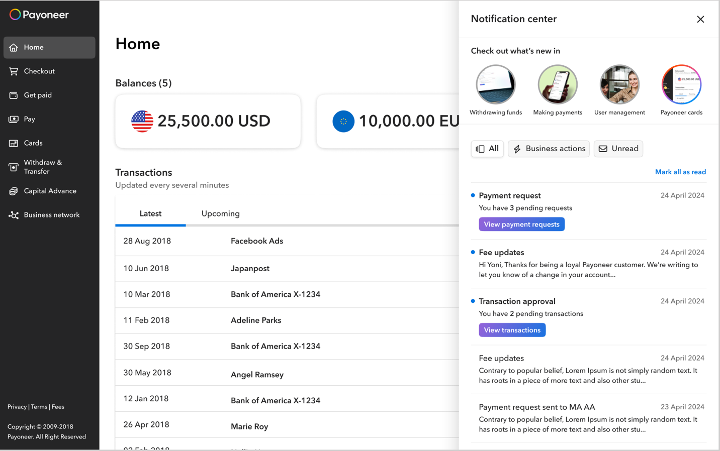

Tour Guide / Tooltip Policy

Date: January 2025
Approval:
Still open:
In production: No (Currently not planned – Jan 2025 – intended to purchase UserPilot)

High-level description of product:

Awareness tool for new capabilities/ features or for new users.

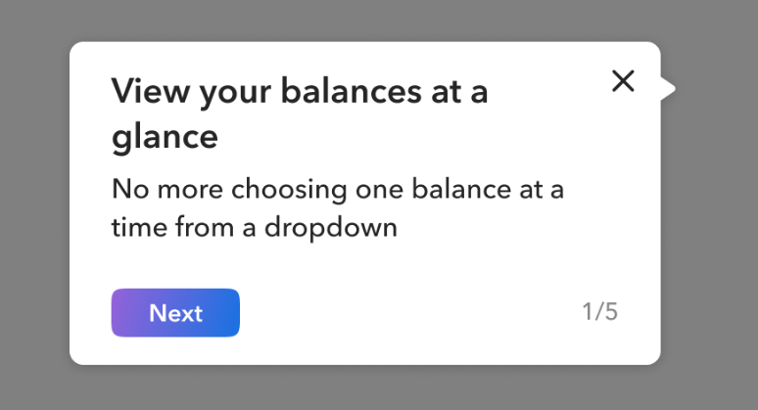

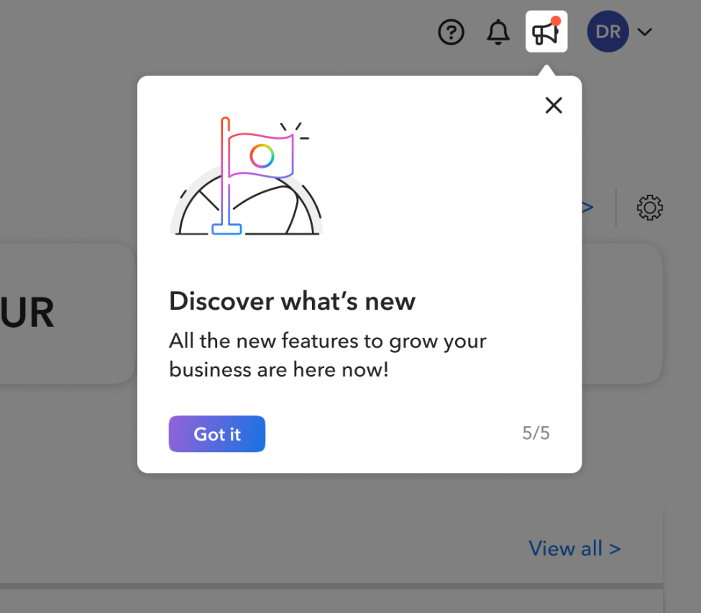
The Tour Guide / Tooltip is an awareness tool designed to introduce new capabilities, features, or guide new users within the platform. It leverages contextual, interactive, and user-friendly overlays to highlight key functionalities, ensuring users can quickly and intuitively familiarize themselves with the product.
This tool serves two primary purposes:
- Enhancing User Onboarding: Streamlining the experience for first-time users by providing step-by-step guidance.
- Promoting New Features: Driving awareness and engagement for recently launched features or updates.
By integrating non-intrusive, informative tooltips and tours, the policy aims to deliver a seamless user experience, improve feature adoption, and empower users to maximize the platform’s value.

High-level product capabilities:

The Tour Guide/Tooltip is a tool for providing users with contextual guidance about new capabilities, features, or updates. It allows the creation of step-by-step tours tied to specific elements on a page, supporting up to 1–5 steps per tour. Tours can include clear calls to action (e.g., "Next" or "Got it") and must be dismissible by the user.
The tool supports up to four tours per account, with only one active tour allowed per page at a time. Tours can be targeted using advanced segmentation capabilities, including user attributes like location, device type, and account characteristics. They can appear across most pages in the system, excluding log-in screens, and selection pages.

Policy Definition:
- KPI? How do we define success?
- Engagement rate: If the tour has more than one step: the rate of clicking on the button that takes you to the next step.
- Adoption rate: The impact on adoption/start of the adoption process of the capability or feature to which the tour was attached
- Approval process - Who can define communication, must sign-off & does testing
- High-level process (draft):
  - Product originates with the request
  - Marketing implements it according to pre-defined governance & policy (& design)
  - Marketing owner pushes to SB
  - Product & QA of the domain the request originated from review it
  - Once approved, Marketing owner pushes to production
- Bugs/issues responsibility
- If issues arise – optimally:
  - All issues will go via SRE:
    - If implementation issue – will be directed to Marketing for rollback
    - If Userpilot/technical issue – will be directed to R&D for support & evaluation (Infra)
- Audience configuration options / restrictions
- Messages allowed
  - Types of messaging (Upsell / Coss-sell / What’s new / UI UX change updates)
    - Currently allowed: upsell /cross-sell new Capabilities or features / UI UX change updates
    - Not allowed: All that is covered by the account alerts: FDC requirement messages, critical messages, or account and payments status warnings.
  - Messaging category (transactional / marketing etc) Transactional not allowed
    - Currently: marketing and UX
  - Call to action definition: CTA allowed, not mandatory. content is limited to: NEXT / GOT IT/ X .
  - Closing option (X) mandatory
- Can disappear if:
  - If you user pressed ‘X’
  - Should disappear, and not return for the same user, after being viewed or closed once (tours are single use)
  - No multiple use tour (cannot be triggered multiple times)
- Queuing
  - Expiration date must exist
  - Can have up to 4 tours in the account, but only one per page.
    - Based on prioritization mechanism (?)
    - When one expires, the next one will appear.
- Appearance policy:
- Only one tour per page is permitted.
- Each tour must point to a specific item on the page—it cannot be general.
- Tours cannot navigate the user between pages.
- A maximum of 4 tours per account is allowed, with only one tour per page.
- Tours can appear on any page except Log-in, Wizards, and Selection pages.
- Tours cannot target open communications like banners, Jumbotrons, etc.
- Tours can include 1 to 5 steps. If more than 1 step, a “Next” CTA must be included.
- Cool off period between notifications
- Reminders (if relevant)
- Ecosystem – Channels:
  - Can appear simultaneously with other channels but cannot appear upon a channel.
  - Cannot appear for an item that already has a upsell/cross-sell/new capability banner
- Vendor information/capabilities:
  - SLA/Support
  - Definition of success
  - Capabilities available
    - A/B testing
- Segmentation capabilities (draft):
  - User ID (Account Holder ID)
  - Device ID
  - Platform
  - Device Type
  - Country
  - City
  - Region
  - Billing_Country
  - user language
  - OS
  - account holder type
  - customer type
  - Entity_Type
  - funding type
  - Have_First_Approve_Date
  - is payer
  - is receiver
  - Is_Complete_Registration
  - Is_FTL
  - Is_ICP
  - Is_FTS
  - Is_Managed
  - Is_Start_Registration
  - kyc level
  - MA_Current_Size_Segment
  - MA_Current_Size_Sub_Segment
  - Primary_Vertical
  - Registration_Category_Desc
  - Registration_Vertical
  - Value_Segment
  - role id

- Risk
  - Mobile-web view needs to be tested
  - A/B testing does not connect seamlessly to LaunchDarkly (will need to be done manually if relevant)
- Design guidelines & limitations –
  - The tour component (with one step or multiple steps) has two optional templates in User Pilot:
    - With an illustration
    - Without illustration.
  - Changing the template and the tour look and feel is not allowed.
  - If using the Tour step with image template, the images allowed are Level 3 Light illustrations from the Design system: https://www.figma.com/design/lQTqPKYHZH5OC0AlmC1xA9/%5BCORE%5D---LIB-Illustrations---all-levels?node-id=142-509&t=nRguKBwoUN9BI9y9-1
    - Do not resize the template illustration (120px x 120px).
  - Content guidlines:
    - Illustration (optional)
    - Title (must) – 80 characters max.
    - Text (must) -– 150 characters max.
    - CTA (must) – primary button with label “Next” when the tour has more than 1 step / “Got it” when the tour has 1 step or this is the final tour step. No other options are allowed.
    - Dismiss button (x) - mandatory
  - If the tour has multiple steps:
    - You must display the step number out of the total
- Accessibility requirements - The template created in UserPilot by the design team meets accessibility requirements.

Banners Policy

Date: January 2025
Approval:
Still open:
In production: No (Currently not planned – Jan 2025 – intended to purchase UserPilot)

High-level description of product: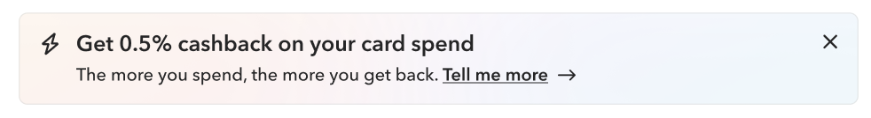
The Banner system is a communication tool designed to enhance user engagement by promoting cross-sell, upsell opportunities, and new capabilities available within the platform. It serves as a dynamic medium to deliver actionable, relevant, and targeted messages to users based on their eligibility and activity. By providing clear, measurable calls to action, banners drive awareness and adoption of key features, ensuring users are informed and empowered to take advantage of Payoneer’s offerings.

High-level product capabilities:

Banners support advanced audience segmentation, allowing for precise targeting based on user attributes such as account type, region, and activity. They include mandatory Call-to-Action (CTA) buttons to enable immediate user adoption and track key metrics like clicks and adoption rates. Banners are limited to one per page but can span multiple pages within an account, and they automatically disappear after user interaction, expiration, or three login sessions without engagement. Lifecycle management features include expiration dates, cool-off periods, and reminders to ensure timely and effective messaging.

Policy Definition:
- KPI? How do we define success?
- CTA click
- Adoption start of funnel
- Adoption (complete)
- Approval process - Who can define communication, must sign-off & does testing
1. High-level process (draft): Do we want someone to orchestrate upsell/cross-sell across the company?
  - Product originates with the request
  - Marketing implements it according to pre-defined governance & policy (& design)
  - Marketing owner pushes to SB
  - Product & QA of the domain the request originated from review it
  - Once approved, Marketing owner pushes to production
- Bugs/issues responsibility
1. If issues arise – optimally:
  - All issues will go via SRE:
    - If implementation issue – will be directed to Marketing for rollback
    - If Userpilot/technical issue – will be directed to R&D for support & evaluation
- Audience configuration options / restrictions
  - Messages allowed: Must include cross-sell and up-sell / new capabilities - which the user is available for
  - Types of messaging (promotion / upsell / what’s new / alerts)
    - Currently allowed: upsell /cross-sell new Capabilities or features
    - Not allowed: UI UX change updates / All that is covered by the account alerts: FDC requirement messages, critical messages, or account and payments status warnings.
  - Messaging category (transactional / marketing etc)
    - Currently: Marketing
  - Call to action definition:
    - Existing capability that the customer is eligible for & can adopt.
    - User must be able to adopt immediately, cannot be in the future
    - CTA must exist & be measured.
    - Closing option (X) mandatory
- Can disappear if:
  - An expiration date must be set for each banner.
  - If the user clicks the ‘X’ to close the banner, it will no longer appear.
  - If the user views the banner but does not interact (neither clicks ‘X’ nor the CTA):
    - The banner will reappear up to two more times upon login.
    - After three login sessions without engagement, the banner will automatically disappear.

- Delivery time (if a limitation exists)
  - Expiration date must exist
- Queuing
- Cool off period between notifications
- Reminders (if relevant)
- Ecosystem – Channels:
  - Cannot appear in the same page as Jumbotron.
  - Can we make Jumbotron disappear if we provide the banner tool?
  - Cannot appear for an item that already has a tour / tooltip
- Appearance policy:
  - Only one banner is allowed per page at a time.
  - Banners can navigate users between pages but cannot direct them outside the MA
  - Multiple banners may be active within an account, but only one can be displayed per page.
  - Banners can appear on all pages except: Log-in pages, Home Page (HP), selection pages, Gate offering (empty state) and Wizards (except on the success page).
  - Each banner must include a Call to Action (CTA).
  - If a user closes the banner by clicking 'X,' it will no longer appear.
  - If a user views the banner without interacting:
    - The banner will reappear up to two more times during subsequent logins.
    - It will disappear entirely after three logins without engagement.
  - If a user clicks the CTA, the banner will no longer appear during the next login.

- Can appear with other communication channels (like alert, etc)
- Cannot appear on other communication channels (like Jumbotron, alert, etc
- Vendor information:
  - SLA/Support
  - Definition of success
  - Capabilities available
- Segmentation capabilities (draft):
  - User ID (Account Holder ID)
  - Device ID
  - Platform
  - Device Type
  - Country
  - City
  - Region
  - Billing_Country
  - user language
  - OS
  - account holder type
  - customer type
  - Entity_Type
  - funding type
  - Have_First_Approve_Date
  - is payer
  - is receiver
  - Is_Complete_Registration
  - Is_FTL
  - Is_ICP
  - Is_FTS
  - Is_Managed
  - Is_Start_Registration
  - kyc level
  - MA_Current_Size_Segment
  - MA_Current_Size_Sub_Segment
  - Primary_Vertical
  - Registration_Category_Desc
  - Registration_Vertical
  - Value_Segment
  - role id

- Risk
- Design guidelines & limitations – TBD (pending tests)
- Accessibility requirements: The template created in UserPilot by the design team meets accessibility requirements.

First-use States Policy (Overview)

The first-use states guide users through upgrade, setup and initial introduction to explain core features, demonstrate the product's unique value proposition and prompt users to their next best action.
As part of our mission to deliver a unified and delightful experience, we've built an infrastructure to create consistent first-use states across all products. This helps customers learn about the benefits of the products, why they should adopt them and seamlessly guides them toward their next steps.

(Currently) 3 types of first-use states:
Different scenarios require a different form of "attack":
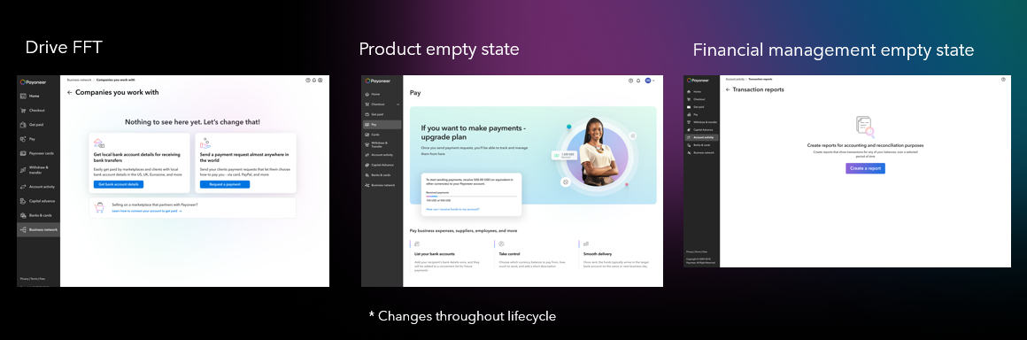

Type | Value | User lifecycle | Location | Requirements | Progress
Drive to FFT | To explain to users the different money-in methods so they can begin using their account. | Relevant from registration until FFT | Areas where the user won't have any relevant information until he/she has money inside their account.  1. Transactions  2. Balances  3. Companies you work with | - Ability to set dynamically money-in products  - Prioritization can be defined  - Eligibility-based  - Infra component | Completed
Product | Emphasize unique product value proposition and prompt users to their next best action. | Changes throughout the user lifecycle - from registration to ongoing.  The 3 main stages:  - Upgrade  - Requirement collection (threshold, withdrawal and/or document submission)  - Introduction to begin using the product. | Financial money-in, money-out & monetized management products - including:  Money-out:  - PON & PON Batch  - MAP & MAP Batch  Money-in:  - Receiving account  - Add funds  - Request a payment  Monetized Management products:  - Role management  - Software integrations | - Dynamic (mostly content) based on customer status/lifecycle  - Component-based (different products can utilize different components based on defined guidelines).  - Eligibility-based  - Infra component  - Visual elements & content will change in different products  - Includes A/B testing capability  Future considerations:  - As products will be unified their empty states must be unified as well.  - Feature benefits configurable based on country? | Not started
Financial management |  | First time to access a financial management area | This will be located in areas where the user can do an financial management action that is NOT a financial standalone product.  1. Reports & statements | - Will be created as a component  - Only relevant in first-entry, after the user uses the product once, we'll transition to an empty state closer to the populated view. | In progress

Drive to FFT First-use State Policy

Date:
Approval:
Still open:
In production: Yes (as of April 2024)

High-level description of product:
The drive to first financial transaction first-use state guide users to add money into the account so they can begin using it’s features. It appears in key areas where the user won’t see any input of significance without first inserting money into the account. Such areas include:
  - Transactions
  - Balance page
  - Companie you work with

High-level product capabilities:
  - Currently 3 money-in options are available:
    - Receiving accounts
    - Request payment
    - Marketplace
  - Prioritization:
    - If the user is NOT eligible to either request a payment OR receiving accounts then the marketplace option will appear in its place:
    - If the user it NOT eligible to BOTH request a payment OR receiving account -- the user will see only an explanation on how to connect their marketplace:

Policy Definition:
- KPI? How do we define success?
  - CTA click rate: Click-through rate on the CTA button within the first-use state
  - Action completion rate (called in notification)
    - 2 KPIs:
      - Start of the funnel
      - Completion to FFT
- Who can define communication
  - Product
- Who must sign off on communication
  - Product
- Audience configuration options / restrictions
  - None – the infrastructure component is based on eligbility and each relevant audience will view a variation of the first-use state based on his/her eligibility.
- Messages allowed
  - Types of messaging (promotion / upsell / what’s new / alerts)
    - Currently allowed: Offering of money-in products so that they user can begin using his/her account.
    - Not allowed: All other types of communication
  - Messaging category (transactional / marketing etc)
    - Currently: Marketing
  - Call to action definition
    - User must be able eligible & can adopt the product immediately, cannot be in the future.
    - CTA must exist & be measured.
      - For marketplace it could be in a form of a link that can be measured
- Delivery time (if a limitation exists)
- Cool off period between notifications
- Reminders (if relevant)
- Ecosystem – Channels
- Does it require a testing period before hand?
- Risk
- Behavior:
  - If the user has received at least 1 USD sometime in his lifetime > the FFT first use state will not appear
  - If the user has received NO money-in throughout his lifetime > the FFT first use state will appear
  - Currently 3 money-in options are available:
    - Receiving accounts
    - Request payment
    - Marketplace
  - Prioritization:
    - If the user is NOT eligible to either request a payment OR receiving accounts then the marketplace option will appear in its place:
    - If the user it NOT eligible to BOTH request a payment OR receiving account -- the user will see only an explanation on how to connect their marketplace:
- Limitations:
  - Money-in products can be added to the pool in the future
  - The design limits it in such a way that only 3 products can be offered at a given point and depending on prioritization – 2 primary products (with primary CTAs) & 1 secondary products (with a link)
- Design guidelines
  - Figma: https://www.figma.com/file/SlK5Bs99fO8pavagj8K44V/Interactive-empty-states?type=design&node-id=0-1&mode=design

Product - Upgrade First-use State Policy (MVP for Upgrade/Offering)

Date: October 2024
Approval: Offering team
Still open: Transparency regarding requirements the user may experience after the ‘upgrade’ state.
In production: Yes (as of January 21st, 2025)

High-level description of product:
The product first-use state guide users through upgrade, setup and initial introduction to explain core features, demonstrate the product's unique value proposition and prompt users to their next best action.
As part of our mission to deliver a unified and delightful experience, we've built an infrastructure to create consistent first-use states across all products. This helps customers learn about the benefits of the products, why they should adopt them and seamlessly guides them toward their next steps.

The vision of the first-use states aim to solve the following main pain-points of existing first-use states:
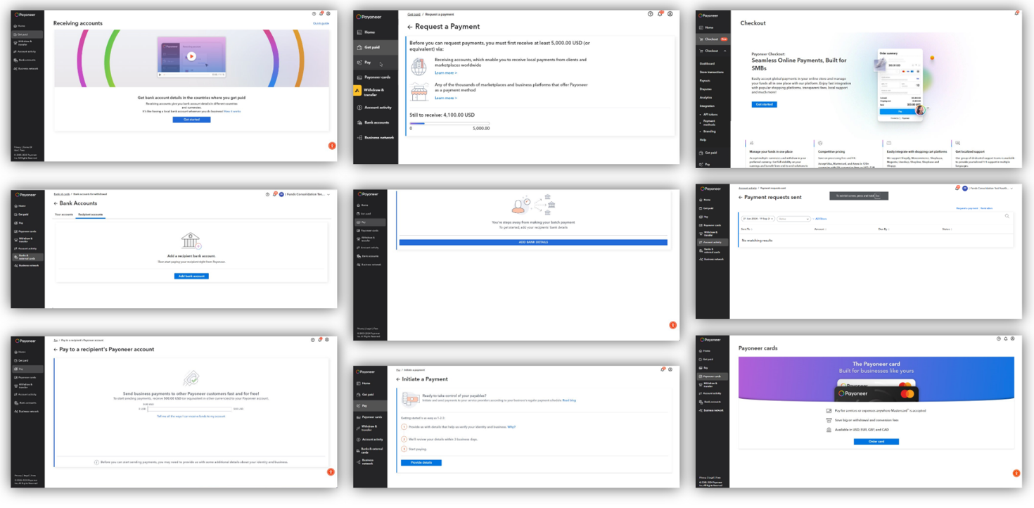
- Inconsistent & cumbersome design and experience -
Each product has its own unique interface and look, which can confuse users and weaken the sense of a brand and unified platform experience.
- No focus on value -
Current empty states fail to motivate users or highlight the benefits, leaving them unsure of what’s in it for them.
- No adaptation to user lifecycle -
First-use states don’t provide personalized prompts based on where the user is in their journey, such as whether they've started onboarding, completed it, or upgraded.

High-level product capabilities:
- The MVP was done specifically for upgrade
- It was done as a ready to use, standardized empty state to increase adoption.
- This comes with customization abilities including- content, graphics, main color and call to action, all based on the stage in the customer's lifecycle.

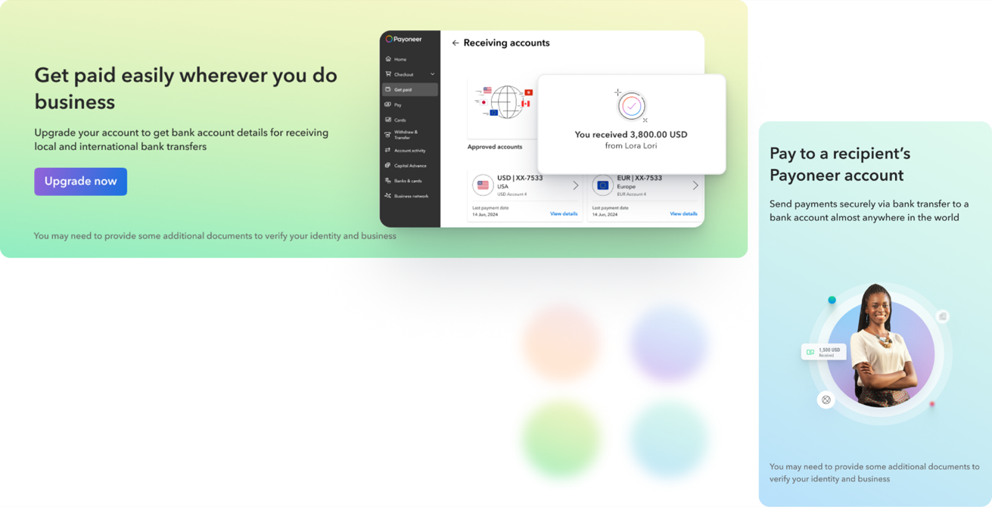

Policy Definition:
- KPI? How do we define success?
  - CTA click rate: Click-through rate on the CTA button within the first-use state
  - Action completion rate (called in notification)
    - Here may need to look at 2 KPIs:
      - Start of the funnel
      - Completion of wanted action
    - Optimally: A/B testing would be integrated into the first-use states & different messaging variations would be applied to allow for continuous optimization of these metrics.
- Who can define communication
  - Currently product along with marketing
  - Future: allow product marketing to optimize the messaging.
- Who must sign off on communication
  - Product
- Audience configuration options / restrictions
  - The MVP is only for audiences that require upgrade and hence currently only available for ‘Lite users’. Specifically for the services:
      - Pay –
        - PON
        - PON Batch
        - PON Amazon
        - MAP
        - MAP Batch
      - Get Paid -
        - BLS
        - PS
        - Self-funding (Add funds)
      - Manage
        - Connect apps
      - Settings
        - Role management
  - Built as an infra component that requires minor configuration & to define content, links & icons:
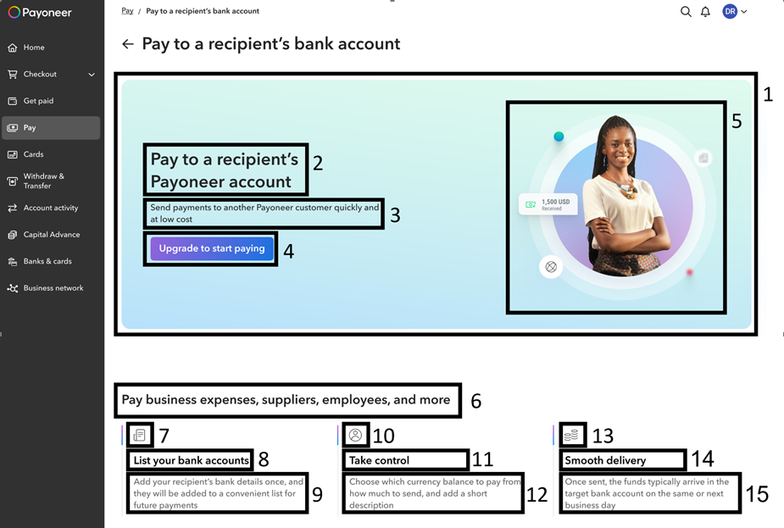
- Implementation guidelines:
  - Configuration guidelines:
    - Banner gradient color –
      - Pay – Blue gradient pallet
        - PON
        - PON Batch
        - PON Amazon
        - MAP
        - MAP Batch
      - Get Paid - Green gradient pallet
        - BLS
        - PS
        - Self-funding (Add funds)- Green gradient pallet
      - Monetized management areas – Orange pallet:
        - Manage- Orange gradient pallet
          - Connect apps
        - Settings- Orange gradient pallet
          - Role management
  - Content configuration:
    - Product title - <<your content here>>
    - Product short description - <<your content here>>
    - CTA – Upgrade now
    - CTA Name - <<Your content here>> (This will use for amplitude event only and will not be displayed to users - click_cta_<<cta name>>)
    - CTA link – <<Sergei insert here>>
    - Graphic element (to be created with Rita’s guidelines and approval) - <<your content here>>
    - Value proposition title - <<your content here>>
    - Value proposition item 1 icon - <<choose from here, or open a PBI for your team to implement new icon in the library>>
    - Value proposition item 1 title - <<your content here>>
    - Value proposition item 1 text - <<your content here>>
    - Value proposition item 2 icon - <<choose from here, or open a PBI for your team to implement new icon in the library >>
    - Value proposition item 2 title - <<your content here>>
    - Value proposition item 2 text - <<your content here>>
    - Value proposition item 3 icon - <<choose from here, or open a PBI for your team to implement new icon in the library >>
    - Value proposition item 3 title - <<your content here>>
    - Value proposition item 3 text - <<your content here>>
  - Implementation guidelines:
    - Make sure you have to have the content you need from Michael’s team
    - Make sure you create the relevant graphic element with your designer and Rita’s approval according to your product and gradient color.
    - Create PBI for your team to implement the empty state configuration with your English resources - example PBI.
    - Once implemented – review the first-use with Rita, Michael and Ze’evik to make sure it matches all the guidelines.
    - Be ready with all of the above in QA and receive approval from the Offering teams.
    - After all approvals send to translations.
    - Review all the translations to make sure the texts are not too long – if the design is harmed in some languages – ask the localization team to try and change the texts to match the design but still match the English content.
    - If you wish to create more empty states for other states – make sure that these states are created in Racheli Henig team and to insert these in the configuration file as described in section 3 and talk to account capabilities team so they will add support to the new state.
  - Amplitude / analytics:
    - There will be 2 events in the empty state:
      - View event – “viewscreen_emptystate”
        - the screen name property will be - <<ProductName>><<State>>EmptyState
    - Click CTA – as described above (CTA name)
- Messages allowed
  - Types of messaging (promotion / upsell / what’s new / alerts)
    - Currently allowed: Marketing of specific products the first-use state is applied to
    - Not allowed: All other types of communication
  - Messaging category (transactional / marketing etc)
    - Currently: Marketing
  - Call to action definition
    - User must be able to adopt immediately, cannot be in the future
    - CTA must exist & be measured.
- Delivery time (if a limitation exists)
- Cool off period between notifications
- Reminders (if relevant)
- Ecosystem – Channels
- Does it require a testing period before hand?
- Limitations:
  - MVP can only be technically managed on the global-level i.e. not per domain. Meaning that taking it to the domain-level would require more development
  - MVP is relevant per product (i.e. PON/PON Batch/MAP etc) not on the menu-item level (i.e. PAY)
  - MVP does not include A/B testing, which should be implemented infrastructurally.

- Risks:
  - Because of lack of time proper user testing wasn’t done on the upgrade first-use states, meaning that we may choose to optimize them.
  - As it was done specifically for upgrade, the continuation experience of the first-use states isn’t optimal and may even be perceived as confusing (each domain has its own first-use states with different behavior, appearance and experience).
  - Today the upgrade first-use states lack transparency as to the continued experience of the rest of the first-use states, i.e. user may pay to upgrade via MAP and then encounter in that same service blocking requirements such as threshold, withdrawal & document collection. Creating a very bad user experience.
- Design guidelines
Figma: https://www.figma.com/design/NM1XUYz4PGmfXNT6yGrWId/Empty-states?node-id=5797-41735&t=fYRgOxcVTVLFqZcX-1

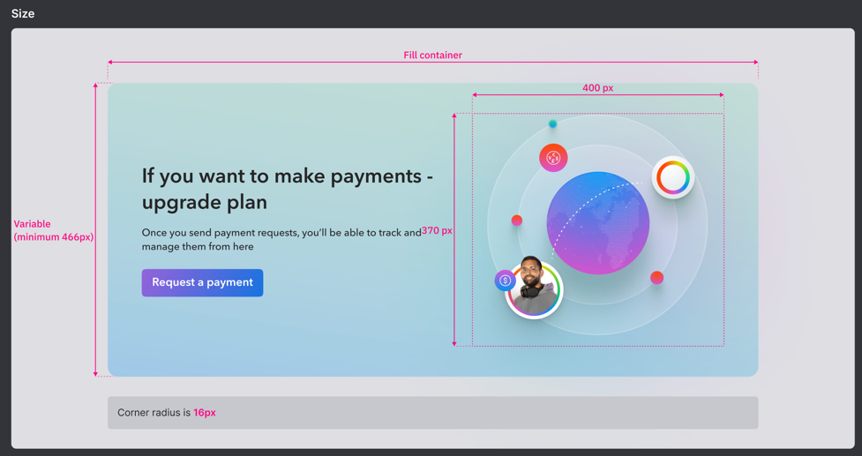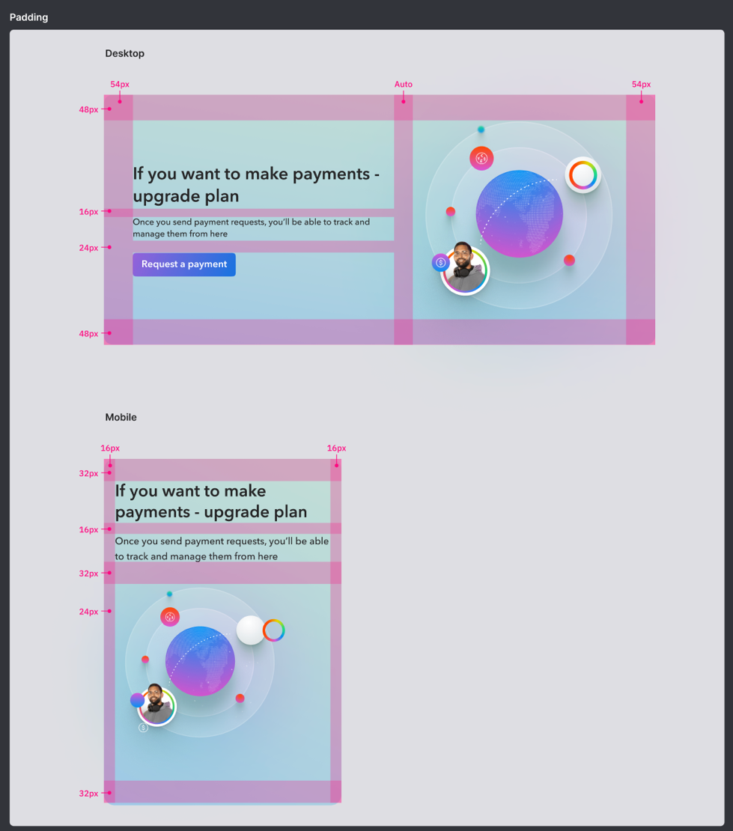
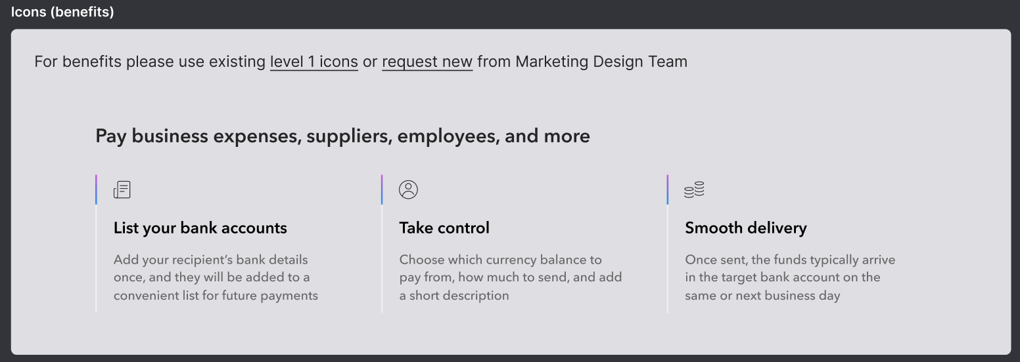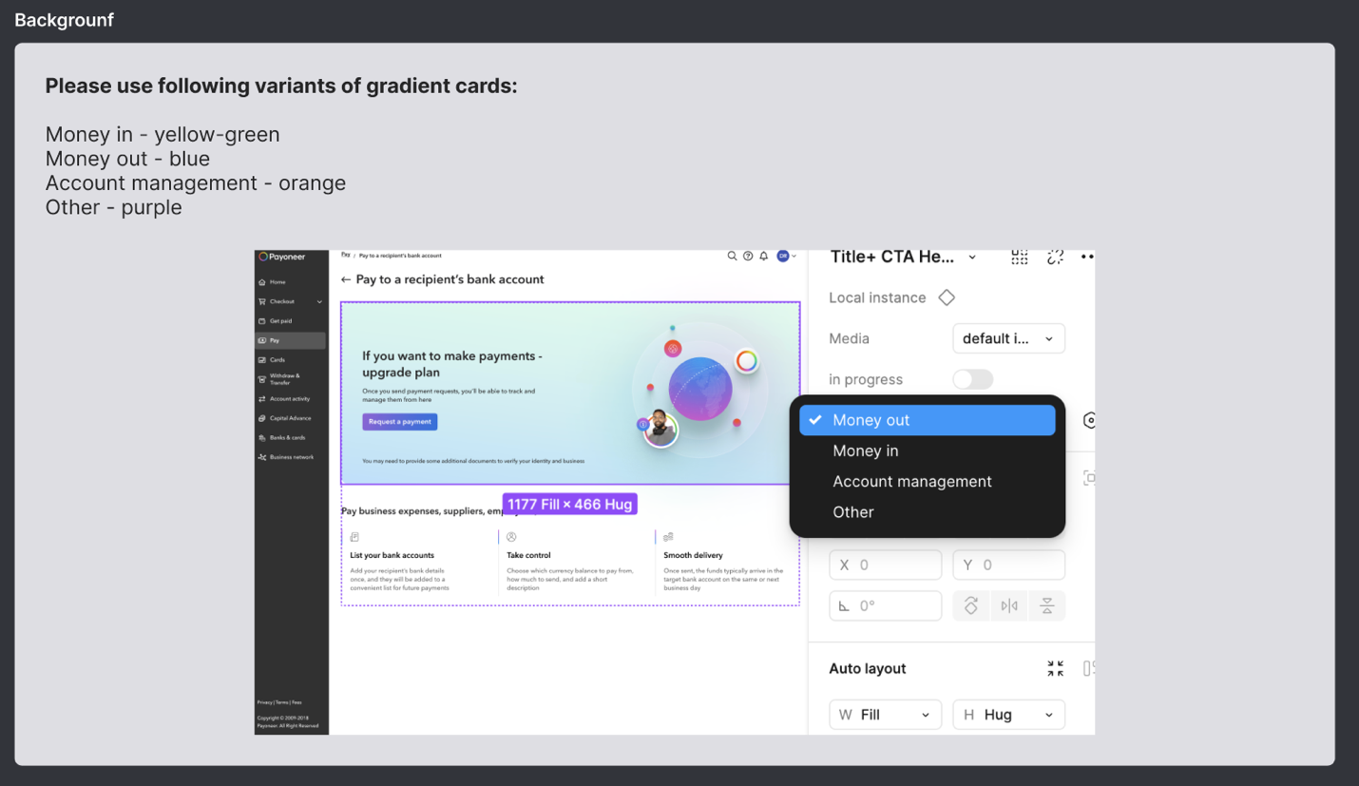

Product First-use State Policy (Vision)
Date: January 2025
Approval:
Still open:
In production: No (Currently not planned – Jan 2025 but has spec)

High-level description of product:
The product first-use state guide users through upgrade, setup and initial introduction to explain core features, demonstrate the product's unique value proposition and prompt users to their next best action.
As part of our mission to deliver a unified and delightful experience, we've built an infrastructure to create consistent first-use states across all products. This helps customers learn about the benefits of the products, why they should adopt them and seamlessly guides them toward their next steps.

The vision of the first-use states aim to solve the following main pain-points of existing first-use states:
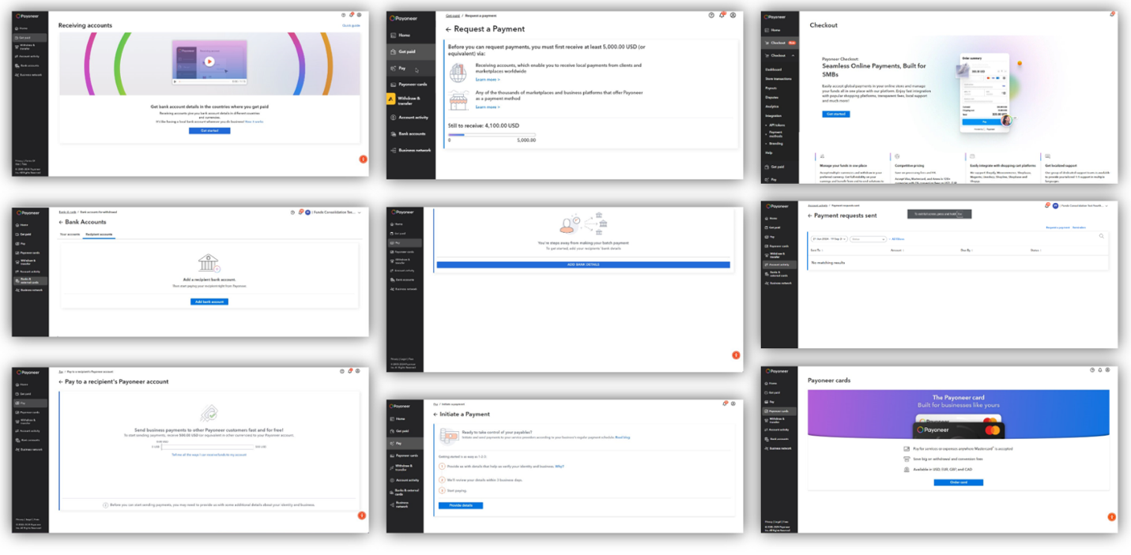
- Inconsistent & cumbersome design and experience -
Each product has its own unique interface and look, which can confuse users and weaken the sense of a brand and unified platform experience.
- No focus on value -
Current empty states fail to motivate users or highlight the benefits, leaving them unsure of what’s in it for them.
- No adaptation to user lifecycle -
First-use states don’t provide personalized prompts based on where the user is in their journey, such as whether they've started onboarding, completed it, or upgraded.

High-level product capabilities:
- In every product / domain (depending on the definition) first use-states adapt to the customer’s lifecycle. Meaning they change in terms of content, possibly structure & call to action depending on whether the user is in one of the following states:
  - ‘First-use state - Upgrade’ - Required to upgrade (developed as MVP) – visual example (WIP):
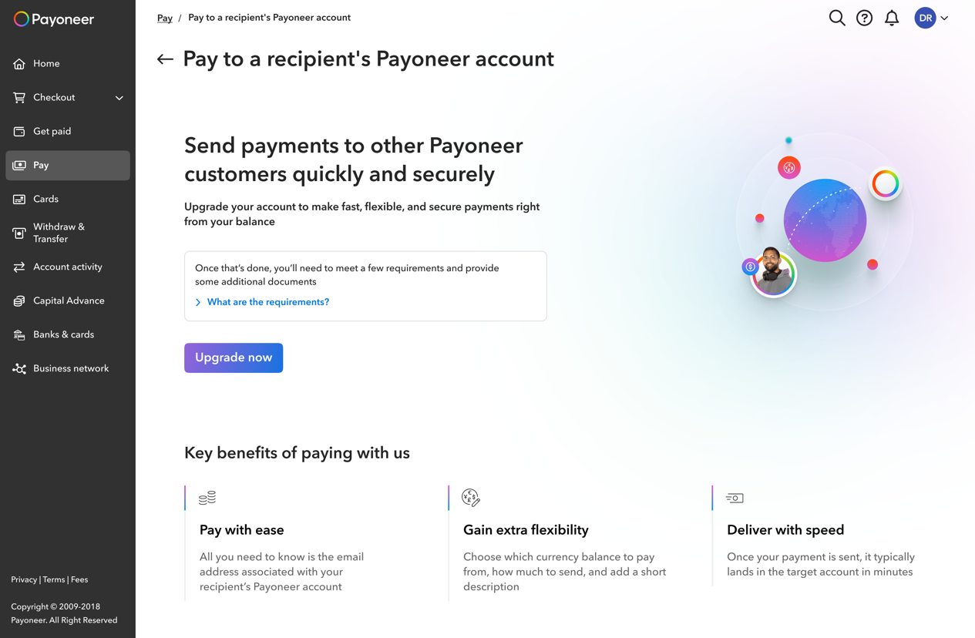
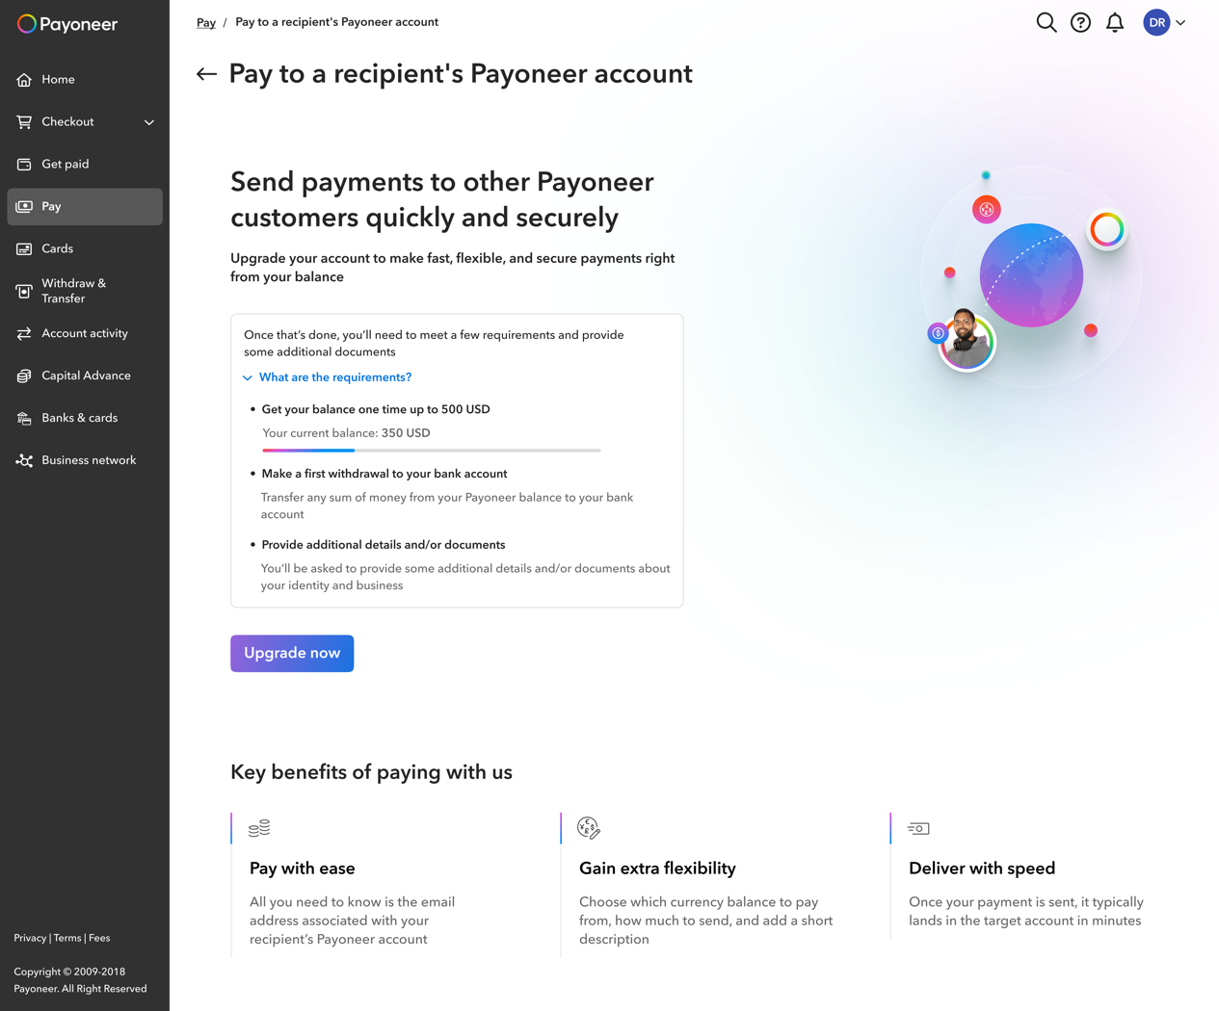
    - Purpose: to drive the user to upgrade by disclosing the value proposition and a clear prompt, while remaining transparent (presenting requirements that will be collected afterwards if such exist).
    - Behavior: the upgrade first-use state will only appear for ‘Lite’ users until they upgrade to the package that includes the feature. It is relevant at the moment for the following features:
      - Pay –
        - PON
        - PON Batch
        - PON Amazon
        - MAP
        - MAP Batch
      - Get Paid -
        - BLS
        - PS
        - Self-funding (Add funds)- Green gradient pallet
      - Monetized management areas -
        - Manage- Orange gradient pallet
          - Connect apps
        - Settings- Orange gradient pallet
          - Role management
    - Can disappear if: The user upgrades to a package where this product is available.
    - Message structure allowed: *Note: the content did not test well. We must create proper content & test it. People tend to ask ‘Why’ we’re asking what we’re asking.
  - ‘First-use state – Requirements’ - Required to complete requirements (i.e. threshold, withdrawal & document collection) - visual example (WIP):
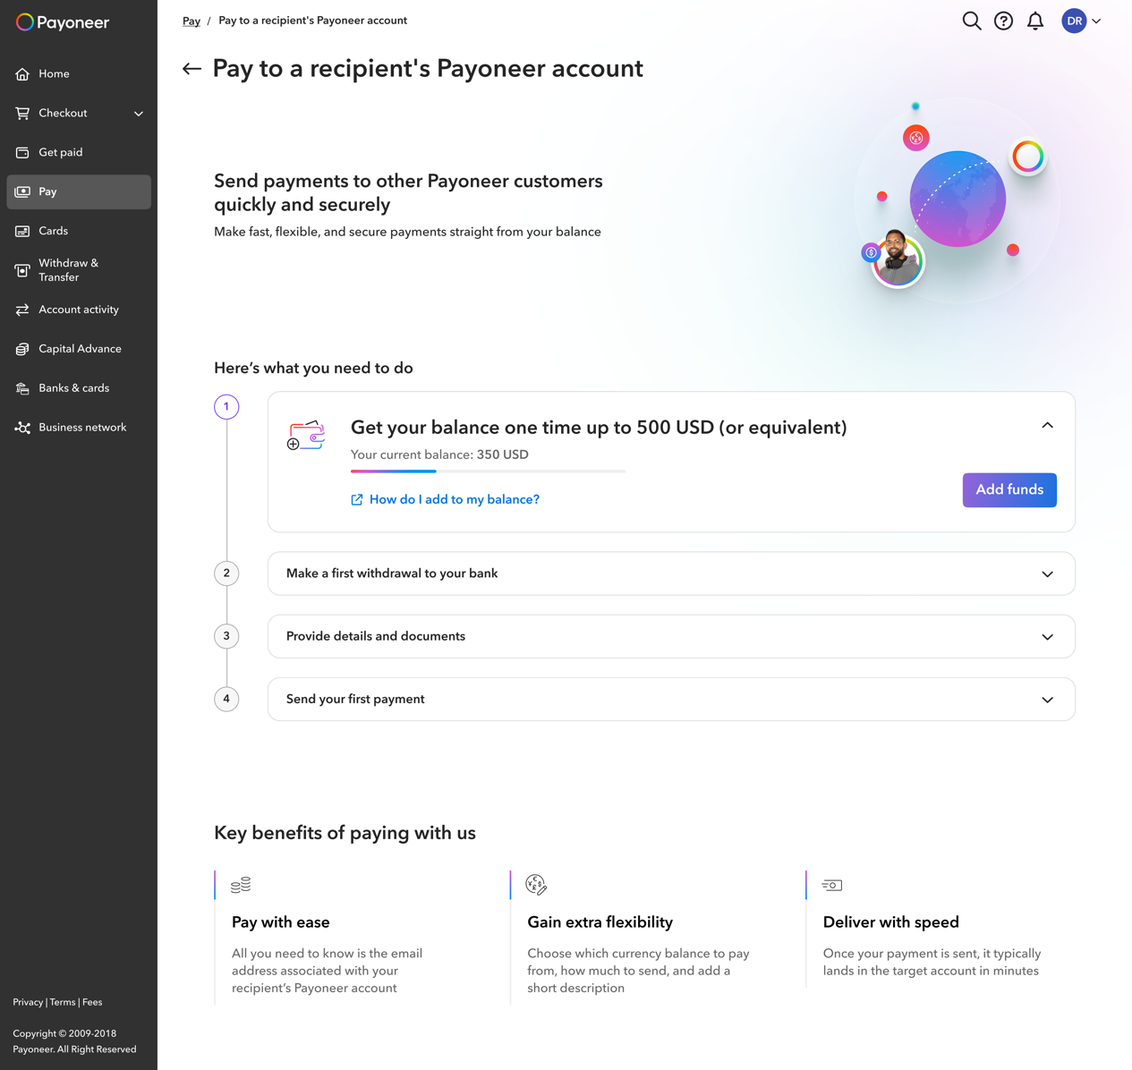
    - Purpose: to drive the user to begin using the product by making it clear what the requirements are to unlock the product and making sure they have a clear next value action.
    - Behavior: Unlike today’s behavior, the idea is to be upfront as much as possible regarding all requirements (i.e. present them simultaneously) and not present them each time seperately in a linear fashion.
      - Note: CLM should remove a lot of the requirements (specifically document collection) but because it won’t remove ALL for ALL audiences this component is still relevant.
    - Can disappear if: The user submits all open requirements, this first-use state will disappear.
    - Message structure allowed: *Note: the content did not test well. We must create proper content & test it. People tend to ask ‘Why’ we’re asking what we’re asking.
  - ‘First use state – Introduction’ - Can begin using the service - visual example (WIP):

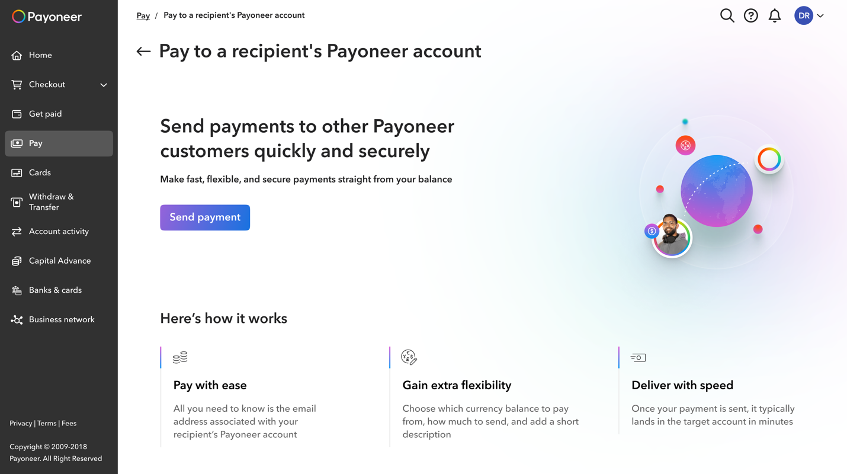

    - Purpose: to prompt the user to start using the service with value-driven content and a clear call to action.
    - Behavior: the introduction first-use state will appear upon first entry to any product.
    - Can disappear if: Once the user clicked that first time, it will disappear and either the existing management interface will appear or a wizard, depending on the area.
    - Message structure allowed: *Note: the content did not test well. We must create proper content & test it.

- Behavior:
  - Appearance of each first-use state:
    - If user is a ‘Lite user’ – only then will the ‘Upgrade’ first-use state will be relevant
    - If user is required to either submit documents, withdraw first or reach a threshold – only then will the ‘Requirement’ first-use state will be relevant
    - If user can begin using the service – only then will the ‘Introduction’ first-use state be relevant.
  - Prioritization:
    - Upgrade appears first, then requirement then introduction.
      - Note: ‘Upgrade’ first-use state includes the ability to see requirements for transparency purposes
    - If one is irrelevant at any stage it simply does not appear and the next first-use state appears

Policy Definition:
- KPI? How do we define success?
  - CTA click rate: Click-through rate on the CTA button within the first-use state
  - Action completion rate (called in notification)
    - Here may need to look at 2 KPIs:
      - Start of the funnel
      - Completion of wanted action
    - Optimally: A/B testing would be integrated into the first-use states & different messaging variations would be applied to allow for continuous optimization of these metrics.
- Who can define communication
  - Product marketing
- Who must sign off on communication
  - Product
  - Product marketing
- Audience configuration options / restrictions
  - First use states appear for the products that the user is eligible for.
  - Each product may have different stages of the first-use state depending if the user must: upgrade or submit requirements.
- Messages allowed
  - Types of messaging (promotion / upsell / what’s new / alerts)
    - Currently allowed: Marketing of specific products the first-use state is applied to
    - Not allowed: All other types of communication
  - Messaging category (transactional / marketing etc)
    - Currently: Marketing
  - Call to action definition
    - User must be able to adopt immediately, cannot be in the future
    - CTA must exist & be measured.
- Content definition & guidelines:

  - Content will change in each product based on the customer’s lifecycle stage:
    - Upgrade
    - Requirements
    - Introduction
  - Header:
    - Title
    - Sub-title
    - Button (with link)
    - Image (not marketing image – should be an image relevant to the understanding of the product – see guidelines below)
  - Content requirements (if relevant)

  - Value proposition:
    - Header
    - Value prop 1:
      - Icon
      - Title
      - Sub-title
    - Value prop 2:
      - Icon
      - Title
      - Sub-title
    - Value prop 3:
      - Icon
      - Title
      - Sub-title

- Delivery time (if a limitation exists)
- Cool off period between notifications
- Reminders (if relevant)
- Ecosystem – Channels
- Does it require a testing period before hand?
- Risk
- Design guidelines:
  - Figma: https://www.figma.com/design/NM1XUYz4PGmfXNT6yGrWId/Empty-states?node-id=5797-41735&t=fYRgOxcVTVLFqZcX-1
  - Product First-Use State – Upgrade:
Note: Transparency & design adjustments were made after testing (not implemented)
  - Figma: https://www.figma.com/design/NM1XUYz4PGmfXNT6yGrWId/Empty-states?node-id=5797-41735&t=fYRgOxcVTVLFqZcX-1
  - The upgrade page has the following elements:
    - A title about the feature (TBD by Content)
    - A subtitle about upgrading (TBD by Content)
    - A disclaimer text and link combo:
      - Has 4 options:
        - If the user will not need to meet any eligibility requirements after upgrading in order to use this feature: no disclaimer text and no requirements link will be displayed
        - If the user will need to meet eligibility requirements: a version of the disclaimer text + the requirements link will be displayed
        - If the user will need to possibly provide documents in the future: a version of the disclaimer text will be displayed + the same requirements link
        - If the user will need to meet eligibility requirements and possibly provide documents in the future: a version of the disclaimer text + the requirements link will be displayed
      - The disclaimer text will change according to the options above (TBD by Content)
      - The requirements link: Small link (blue) with fixed text (“Check the requirements”). Clicking it will open a:
        - Popup/accordion with the eligibility requirements this user will need to meet in order to use this feature after upgrading
        - The popup/accordion will include:
          - Icon (if popup): level 4 light
          - Title (if popup): (TBD by Content)
          - Bullets with the requirements (a bullet each). Each bullet will include:
            - Icon: font awesome
            - A fixed title for each requirement (TBD by Content)
            - A fixed text for each requirement (TBD by Content)
              - The Threshold requirement, instead of text will include:
                - A progress bar
                - Text about the user’s current balance
          - CTA: “Got it” (if popup):
    - CTA button to upgrade: fixed text for all features to upgrade (TBD by Content)
    - Image: the image has fixed size, and for each feature a new image should be provided marketing (needs to be aligned). The image should be informative, a feature demo, rather than a marketing image
    - Benefits title for this feature
    - Three benefits for this feature, that each will include:
      - Icon: Level 1 light icon
      - Title: no more than 4 words (32 characters maximum)
      - Text: 3 lines maximum (120 characters maximum)
      - Need to define here the relevant new pallet for every domain if we remove the gradient so it speaks the same language as the rest of the first-use states.

  - Product First-Use State – Requirements:
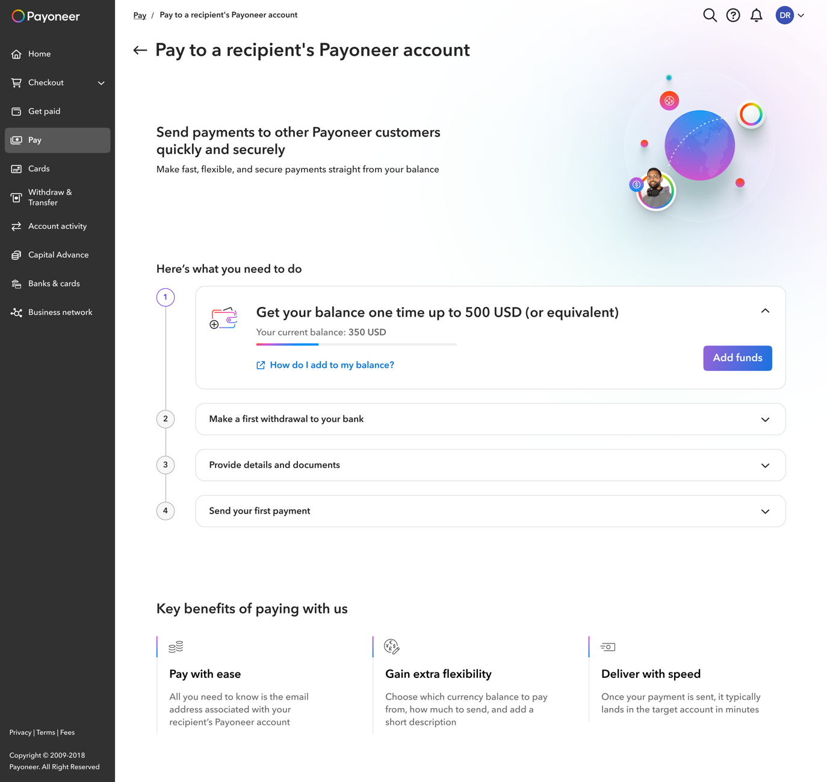

    - The requirements page has the following elements:
      - A title about the feature (TBD by Content)
      - A subtitle about upgrading (TBD by Content)
      - Image: the image has fixed size, and for each feature a new image should be provided by marketing (needs to be aligned). The image should be informative, a feature demo, rather than a marketing image
      - The requirements component (TBD)
        - Latest test findings: Eligibility 3.pptx
  - How to use title for this feature
  - Three steps for this feature, that each will include:
    - Icon: Level 1 light icon
    - Title: no more than 4 words (32 characters maximum)
    - Text: 3 lines maximum (120 characters maximum)
    - Logic & requirements (after discovery):
      - Type of Requirements per Service:
        - Make a withdrawal to enjoy this feature (MAP, Cards & PON)
        - Threshold (BLS, MAP & Cards)
        - Threshold & documents (BLS & MAP)
        - Threshold & withdrawal (Cards)
        - Document collection (BLS, MAP & PS)
        - Add bank & verification of bank (for W2B, PON Batch) - PON circumvented this.
        - Use-case mapping (MAP): https://miro.com/app/board/uXjVLLFq0GQ=/?share_link_id=73250896291
      - Prioritization:
        - PS & BLS > collection & after threshold verify
        - MAP > collection & verification (not MAP batch)
        - Working capital > Bank statement - when the customer has one store - it'll be relevant.
        - Add details. - Shir will check.
        - Verified, can receive offer, 24 hours - can receive but doesn't have offers.
          - Status.
      - Hosting qualifications:
        - If rejected & reopen > show step 1 again (with requirements)
        - If rejected (only reason is due to fraud) > menu item disappears & receives email.
      - Possible Call to Action for Threshold Requirement:
        - PAY MAP - CTA for threshold (based on eligibility) - prioritization of CTAs:
          - BLS (Request payment)
          - Receiving account
          - Mass payout (not a CTA)
          - Responsibility: Gal
        - GET PAID - CTA for threshold BLS - prioritization of CTAs:
          - Add funds
          - Receiving accounts
          - MAP
          - Responsibility: @Michal Inbar
        - GET PAID - CTA for threshold PS:
          - Not needed
          - CLM - shouldn't be stopped
          - CLM - didn't put qualification ahead of time.
          - Responsibility: @Chen Averbuch & @Yoel Berger
      - FAQ & ability to represent simultaneous requirements:
        - BLS (Payment request):
          - FAQ:
            - Fees (will be helpful)
              - Doesn't exist today
          - Simultaneous requirements:
            - If CLM - Threshold & documents not relevant
            - Non-CLM - don't want to collect documents before threshold. Inform of future collection of documents & therefore don't show simultaneously.
        - PS (receiving accounts):
          - FAQs:
            - 'How it works' for PS > opens pop-up
            - Chen will find data on CTA clicks & FAQ clicks
          - Simultaneous requirements:
            - Don't have simultaneous requirements
        - MAP
          - FAQs:
            - Have "Tell me the ways I can receive funds"
              - FAQ links: https://dev.azure.com/Payoneer/Payoneer/_workitems/edit/615185 (Gal will check click data)
          - Simultaneous requirements:
            - If CLM - Documents aren't collected - only threshold & withdrawal will exist (Gal needs to check if can pull simultaneously the requirements.
        - Non-CLM - Don't want to collect documents before threshold (only threshold & withdrawal will be simultaneously). Inform of future collection of documents & therefore don't show simultaneously.
        - Cards
          - FAQ:
            - Currently has "Tell me the ways I can receive funds" (not sure if this is what he wants to keep- Nathan needs to get back to us)
          - Simultaneous requirements:
            - Currently displays withdrawal & threshold simultaneously - so have this ability (Cards doesn't have document collection).

  - Product First-Use State – Introduction:
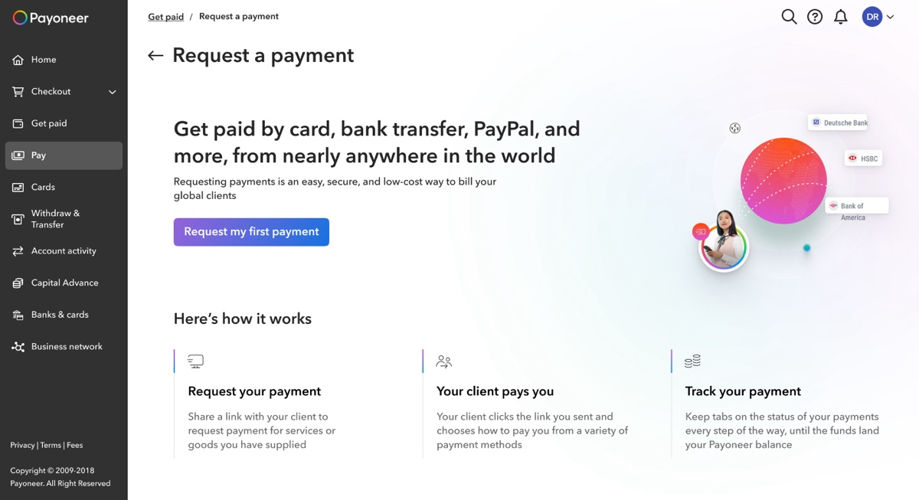

    - The Introduction page has the following elements:
      - A title about the feature (TBD by Content)
      - A subtitle about the feature (TBD by Content)
      - CTA button to use the feature for the first time (TBD by Content)
    - Image: the image has fixed size, and for each feature a new image should be provided by marketing (needs to be aligned). The image should be informative, a feature demo, rather than a marketing image
    - How to use title for this feature
    - Three steps for this feature, that each will include:
      - Icon: Level 1 light icon
      - Title: no more than 4 words (32 characters maximum)
      - Text: 3 lines maximum (120 characters maximum)

Financial Management First-use State Policy
Date:
Approval:
Still open:
In production: Yes (in reports specifically since September 2024)

High-level description of product:
The financial management first-use state is meant to provide a soft entry to financial management areas that aren’t monetized financial products. Such items include reports, whereby we don’t want to overwhelm the user with too many benefits, on the one hand (like in the product first-use state), however, we do want to explain the high-level capabilities available to them.

High-level product capabilities:
A very simple & clean first-use states with an icon, title, sub-title & button to begin using the feature.
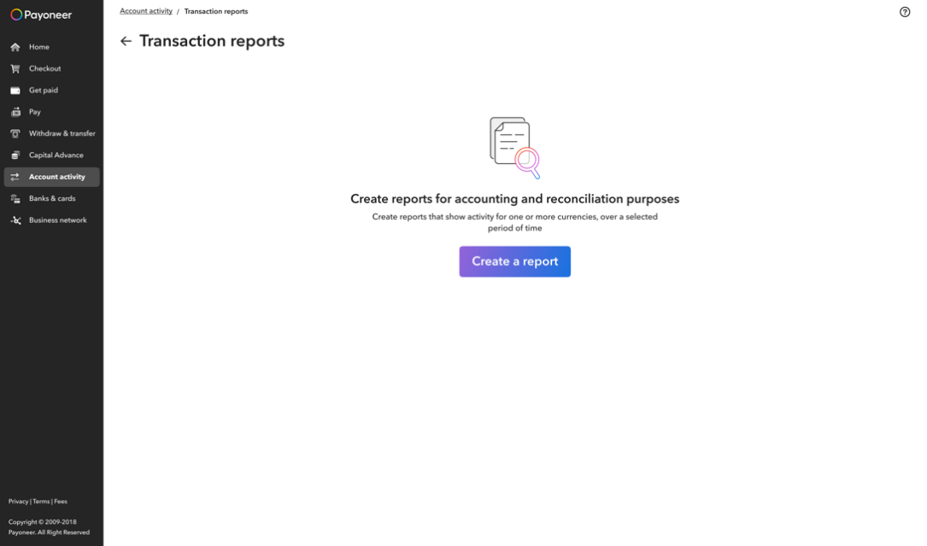

Policy Definition:
- KPI? How do we define success?
  - CTA click rate: Click-through rate on the CTA button within the first-use state
  - Action completion rate (called in notification)
    - Here may need to look at 2 KPIs:
      - Start of the funnel
      - Completion of wanted action
    - Optimally: A/B testing would be integrated into the first-use states & different messaging variations would be applied to allow for continuous optimization of these metrics.
- Who can define communication
  - Product marketing
- Who must sign off on communication
  - Product
  - Product marketing
- Audience configuration options / restrictions
  - None
- Messages allowed
  - Types of messaging (promotion / upsell / what’s new / alerts)
    - Currently allowed: Marketing/value proposition of specific management capability that the first-use state is relevant for.
    - Not allowed: All other types of communication
  - Messaging category (transactional / marketing etc)
    - Currently: Marketing
  - Call to action definition
    - CTA must exist & be measured.
- Content definition & guidelines:
  - All financial management first-use states include:
    - Icon
    - Title
    - Sub-title
    - CTA
- Delivery time (if a limitation exists)
- Cool off period between notifications
- Reminders (if relevant)
- Ecosystem – Channels
- Does it require a testing period before hand?
- Risk
- Appearance:
  - This first-use state will disappear after a report is created, or after 2 years since last report created.
  - Theoretically can also disappear after first click on the CTA.
- Design guidelines
  - Figma: https://www.figma.com/design/wPGcUcTi7jwSMDGDRQopNc/New-report-page?node-id=2673-14350&t=vtxlkXoURAbdZqRn-1

